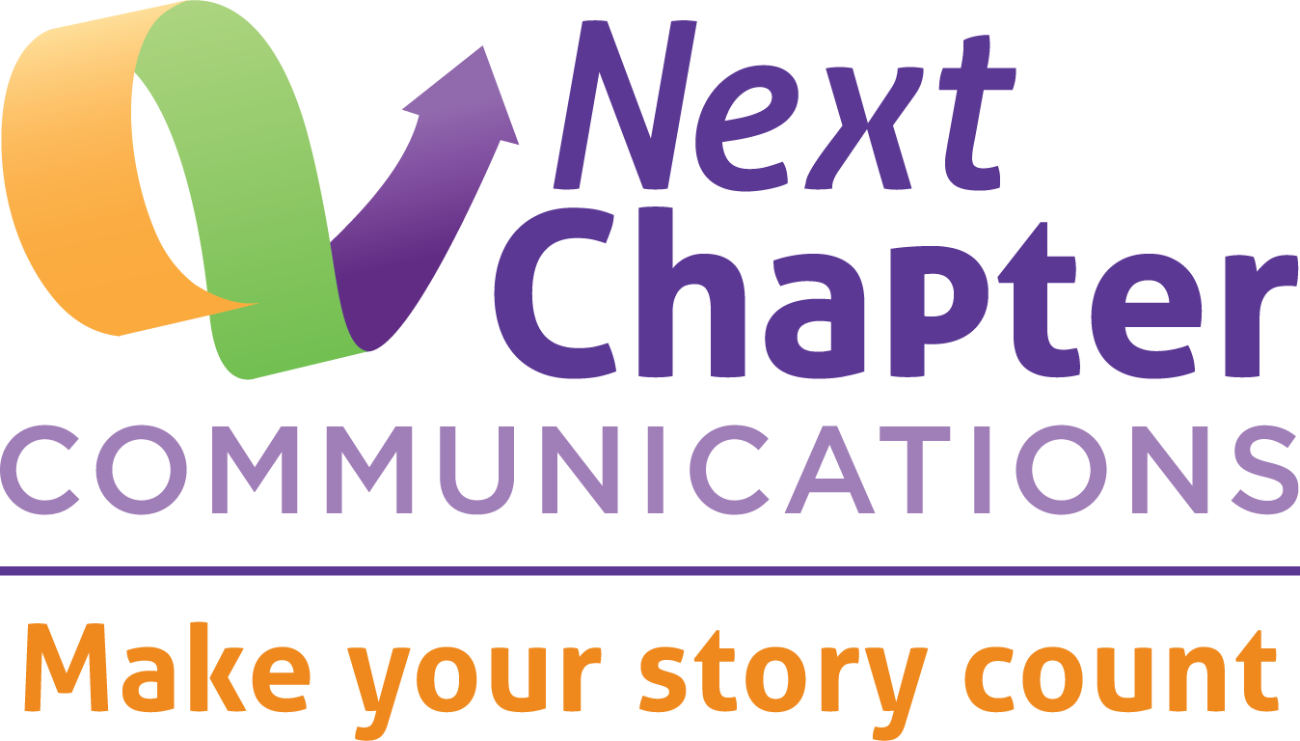
Texas Pathways Communications Pre-Institute
November 6, 2019
Goals Worksheet

All communications work begins with organizational goals. To plan your pathways communications strategy, begin with your college’s pathways goals. Then develop communication strategies based on those goals.

Using the chart below, write one or more of your college’s pathways goals. Then add communications strategies that can help you attain the pathways goal.

Reminder: the most useful goals are specific, action oriented, and measurable.

EXAMPLE

College Goal for Pathways Work | Communications Strategies
Identify [specific number] faculty and staff members to lead program mapping in each department | Go beyond email to mobilize faculty and staff.
 | Communicate the value of pathways work and the essential role of faculty in mapping so faculty volunteer.

YOUR COLLEGE

College Goal for Pathways Work | Communications Strategies

Texas Pathways Communications Pre-Institute
November 6, 2019
Audiences Worksheet

Using the space below, write the audiences that fit in each ring for your pathways work. Consider which audiences you want to mobilize as your work progresses, and remember that each new audience you engage can reach out to new people.

As you consider your audiences, be specific. For example, if you want to mobilize faculty, which faculty? Deans? Department chairs? Specific departments? Are you considering part-time faculty?

Brainstorm beyond the usual suspects. Student success is everyone’s job.

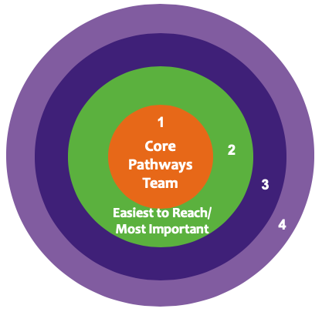

Ring 1. Core Pathways Team
Is everyone on the core pathways team well informed? Are there any members who need to be more fully in the loop?

Ring 2. Easiest to Reach/Most Important
Who is essential for the next steps of the work? Who is ready to jump in now?

Ring 3
What audiences come next as the work progresses? Who can audiences in ring 2 bring to the table?

Ring 4
What audiences come next as the work progresses? Who can audiences in ring 3 bring to the table?

Texas Pathways Communications Pre-Institute
November 6, 2019
Strategic Communications Planning Worksheet
Effective communications is an essential element of implementing pathways, but resources to do this work (people, time, money) are limited. Use this worksheet to set priorities and plan strategically. Then monitor progress toward your communications goals over time.
Your communications strategy should be based on your college’s pathways goals. Write the pathways goal at the top of the chart. Then, start working left to right. It can be tempting to jump to column 5 and say, for example, “We need an e-newsletter.” Perhaps you do. But first be clear about your audiences and what you want them to do in the service of your pathways goal. Use connections between your needs and your audiences’ needs to engage them. And do not neglect columns 6 and 7. Being realistic about timelines and workloads is essential, as are gathering feedback and revising your outreach accordingly.

PATHWAYS GOAL: |  |  |  | Who completed this worksheet:
 |  |  |  | Today’s date:
1 | 2 | 3 | 4 |  | 5 | 6 | 7
Target Audience | Your needs  What do you want this audience to do? | Audience needs  What do they need or want to happen? | Relevant messages |  | Comms strategies, tactics, and tools | Implementation  Timeline, cost, who does what | Evaluation  How to get feedback & measure success

