All parts of the Short-Term Action Plan document will be drafted during the institute. Following the institute, team leads will engage key college stakeholders to complete a final version of the plan and return a copy of this complete document to the Texas Success Center at success@tacc.org by May 9, 2018.

Complete Parts I-A & I-B During Team Strategy Session #1
Notes will be used in subsequent team conversations as you move toward action planning.

Part I-A: Understanding Students’ Experiences
Review and reflect on key performance indicators (KPIs) reported in advance work. Discuss and record notes on the following questions.

Key Performance Indicators
Guiding Questions | College Responses
What do the data indicate about your students’ experiences, especially their earliest experiences with the college? | - Connect data:  - Enter data:  - Progress data:  - Success data:  - Adult Ed. data (optional):
What do the disaggregated student population data indicate about the equity of their experiences?

Part I-B: Back Mapping to Endorsements and the Right Dual Credit
Review and reflect on your advance work mapping meta-majors to high school programs and identifying dual credit courses that best align with those programs. Discuss and record notes on the following questions.

ENDOSEMENT AND DUAL CREDIT MAPPING
Guiding Questions | College Responses
- How much information on mapping high school endorsements to meta-majors already existed for students and advisors? What more is left to complete?
- Is high school to college mapping integrated with your transfer and employment information?
- Have faculty in meta-majors/program areas collaborated with K-12 colleagues on the alignment of endorsements? If not, how will you engage faculty in that work?
- Have faculty in meta-majors identified the right dual credit including the right math (e.g., statistics, quantitative reasoning, college algebra/calculus) aligned to programs in that area? If not, how will you engage faculty in that work?
- At what point are public school students directed to information about how endorsements map to meta-majors? How does/will your college partner with school districts to get information to 8th grade students as they choose their endorsement plan?
- If/when the information about endorsements to meta-major pathways is available, where can/will students find it?
- Is the information clear and transparent for high school students, their families, and high school advisors?

Complete Part II-A & II-B During Team Strategy Session #2
Notes will be used in subsequent team conversations as you move toward action planning.

Part II-A: Planning for Successful Corequisite Scaling
Using the Corequisite Visioning Worksheet completed as advance work, your team 1) identified established capacities for change that will support the successful and sustainable scaling of corequisite models, 2) anticipated areas that will need specific strategic attention, and 3) surfaced outstanding issues for consideration. Now, review your visioning worksheet responses, discuss and record notes on the following questions.

Corequisite Visioning  Guiding Questions | College Responses to Guiding Questions
- Early and broad engagement will be key to successful implementation. In addition to faculty, who is currently engaged in planning and building corequisite offerings? Who else should be included?
- What supports/resources do faculty need to encourage adequate collaboration in designing and implementing effective corequisite supports?
- Once implemented, what early indicators will identify students who need additional support? What will that support look like?
- Knowing many underprepared students do not regularly seek assistance from tutoring and writing centers, what mandatory, embedded, or other academic support might your scaling strategy include?
- What data will you need to evaluate the effectiveness of corequisite offerings? How will you ensure the data are available and useful to faculty and administrators?

Part II-B: Ensuring Low Skill Students are Included in Your Comprehensive Student Success Strategy
In recognition of the wide variety of service providers and academic offerings for the most underprepared students, the following questions are designed to guide your team in reviewing the current state of services in your community and your institution, determining the need for redesigned or enhanced offerings, and assessing how these supports are embedded in the college’s pathways reform. For the purposes of this discussion, any student exempted from developmental/corequisite offerings—students assessed and reported at levels 1-4 on the ABE diagnostic of the TSI Assessment, students enrolled in a BASE NCBO, and students enrolled in Adult Education programs—are identified here as low skill students.

ALigning Adult Education  Guiding Questions | College Responses to Guiding Questions
- Who currently provides academic services and support to low skill students in your institution? In your community? Do the key stakeholders who support the success of these students collaborate with each other and share the institution’s pathways vision?
- Have faculty in meta-majors/program areas collaborated with low skill student or AEL instructors to ensure alignment of courses and student learning outcomes?
- Do low skill students have clear maps from their current supports into meta-majors? Do these maps include credential, transfer, and employment information?
- In preparing advance work KPIs, what did you learn about the availability of data and data sharing among low skill instructors/AEL directors and related college level faculty and administrators? What could improve data collection, analysis, and usage?

- What one to three data points on low skill student success might be included in regular reports on all students?

Complete During Team Strategy Session #3

Part III: Making Sense and Moving Forward
Your team’s discussions should now turn from information gathering toward action planning by synthesizing the work to this point. Consider highlights from your notes on key performance indicators, endorsement and dual credit mapping, corequisite visioning, regional meeting discussions, plenary sessions, and concurrent sessions at this institute. To ensure all appropriate voices are included, consult the Engagement Scan your team completed as part of your advance work. Use the following questions to guide discussion. Facilitated discussion will highlight divergent and convergent perceptions, leading toward team consensus.

Pre-Planning Synthesis  Guiding Questions | College Responses to Guiding Questions
Which issues/approaches/strategies discussed in the day’s sessions are potentially of greatest interest to the college?
What existing knowledge and/or college work has been reinforced?
Discuss insights the team has gained from these conversations. As a team, determine three to five key insights.
What do you need to learn about these issues/approaches? How will you obtain that information? What technical assistance and/or professional development will the college require?

Planning Ahead for Texas Pathways Round 2: The Texas Success Center, with generous funding from the Greater Texas Foundation, T.L.L. Temple Foundation, Teagle Foundation, Houston Endowment, and the Bill & Melinda Gates Foundation, will kick off Texas Pathways Round 2, the final three years of the five-year strategy, beginning fall 2019. This ongoing statewide strategy will continue to focus on building capacity for community colleges to design and implement structured academic and career pathways at scale, while also including new and challenging supports for colleges as they implement, evaluate, and improve scaled pathways for all students. This team strategy session provides time for your team to discuss what you have left to accomplish during the last year of Texas Pathways Round 1, the 2018-2019 academic year, to be ready to apply for Texas Pathways Round 2 support.

In the summer of 2019, the Texas Success Center will make available an advanced rigorous application process to provide all Texas community colleges the opportunity to advance into the next round of supports in implementing guided pathways at scale. Texas Pathways colleges that demonstrate (1) significant progress toward scaling during Texas Pathways Round 1 and (2) the readiness capacity to evaluate the quality and effectiveness of newly implemented changes and commit to making strategically targeted improvements will be selected to participate in cadre 1.1. Likewise, the Center will re-release the original rigorous application for cadre 1 support, open to any cadre 2-4 college. Texas Pathways colleges able to demonstrate the readiness capacity and the commitment to implement pathways at scale will be selected to participate in a new set of colleges of cadre 1.2.

All Texas community colleges will also have the option to move into cadres 2-4, determined by the need and readiness capacity for these targeted supports. Below is a list of institutes planned for the final year of Texas Pathways Round 1 and the three years of Texas Pathways Round 2’s structured support strategies. As a team, use the guiding questions below to facilitate a discussion about what your college will need to accomplish next year to be prepared for the second round of guided pathways support.

Round 1 Round 2
Institute #5: November 2018 Institute #1: November 2019
Institute #6: April 2019 Institute #2: April 2020
Institute #3: November 2020
Application Process: Summer 2019 Institute #4: April 2021
Awards Announced: July 2019 Institute #5: November 2021
Institute #6: April 2022

Pathways planning
As your team reflects on all you have accomplished so far in Texas Pathways Round 1 and looks ahead to Round 2, note areas to include in your 2018-19 strategic planning, such as (1) leadership for institutional change, (2) mapping through the institution, (3) pathways to transfer and employment, (4) front door academic success (K-12, adult and developmental education), (5) academic advising for students to get on and stay on a path, and (6) ensuring student are learning.

Begin During Team Strategy Session #4 and Complete With Other College Stakeholders

Part IV: Identifying Priorities and Action Planning
At this point, your team has reviewed and discussed (1) implementing and advancing programs aligned with high school endorsements and the right dual credit courses, (2) the best strategies for implementing corequisites for underprepared students, (3) how to close gaps between adult education and college level courses, and (4) how to improve equity at your institution. Now comes an opportunity for the team to reflect on its learning, think through options for the college’s strategic approach to designing and implementing guided pathways at scale, and establish new or refined priorities for the work on campus. The college team should discuss next steps: whom to involve, how to communicate findings and broaden engagement on campus, and how, when, and by whom follow-up steps will be taken.

The action planning template is provided for more detailed planning that will identify priorities/strategies/goals, activities, key personnel, timelines, resources, and potential issues for designing and implementing guided pathways at scale. Add rows as necessary.

Following the institute, and once you’ve engaged key college constituencies in discussion of data, issues and strategies, please return a copy of this entire document to the Center (success@tacc.org) by May 9, 2018.

OUR 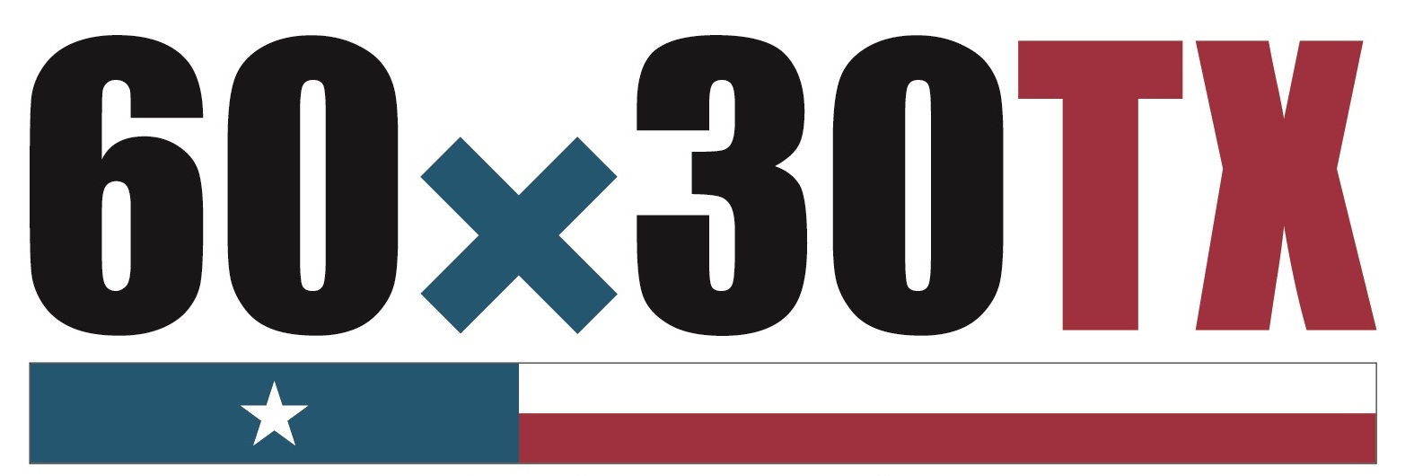 PLAN
For Early Academic Success

Priorities  NEXT STEPS | BY WHOM | BY WHEN

OUR PLAN
For Early Academic Success

ACTION PLANNING  Priority/Strategy | Goal(s) | Activities/  Tasks | Responsible Person(s) | Timeline |  | Resources | Potential Issues or Concerns
Identify top priorities for next steps in the work | Based on these priorities, name specific desired student outcomes | List steps required to accomplish these priorities | Who will assume leadership responsibility? | Implementation date | Formative evaluation date | What resources (time, people, facilities, and money) need to be allocated/reallocated? | What challenges do you anticipate?
1.
2.
3.
4.
5.
6.

