**Team Strategy Time #2: Cadre 1**

**What does the Data Tell Us?**



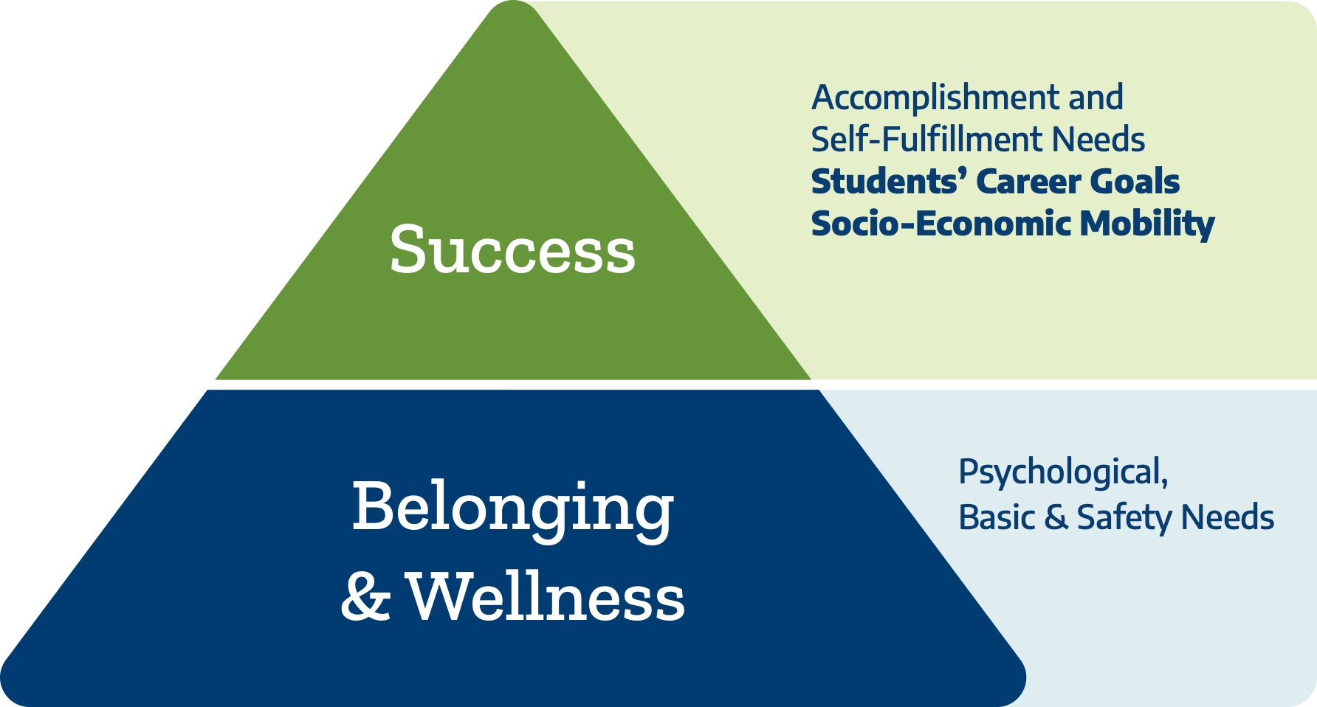



Belonging and Wellness include addressing institutional barriers concerning students’ insecurities in housing, food, transportation, financial need, mental health, and childcare. Colleges must attend to students’ basic needs as a significant impediment to completion and post-completion success.

In this Team Strategy Time, you will: (1) review your college’s basic needs insecurities data, (2) review your college’s credit attainment data, and (3) analyze and synthesize your data and reflections related to onboarding processes for transitioning students.

**Understanding Basic Needs Insecurities at Your College** (~ 30 minutes)

Using basic needs survey data, your college leadership team will evaluate the systems in use to understand student basic needs insecurities at your college.

* Provide the top five areas of student basic needs insecurities based on the basic needs survey completed at your college.
* Identify the resources and services provided by the college or through partnerships.
* Lastly, detail how the college identifies student needs and monitors the utilization of resources and services.

|  |  |  |  |
| --- | --- | --- | --- |
| **Exploration of Students’ Basic Needs & Institutional Systems** | | | |
| **Top Five Areas of Student Basic Needs** | **Resources and Services Provided by the College** | **Systems to Identify Student Basic Needs** | **Systems to Monitor Student Utilization of Resources and/or Services** |
| 1) |  |  |  |
| 2) |  |  |  |
| 3) |  |  |  |
| 4) |  |  |  |
| 5) |  |  |  |

Identify students from different demographic groups in the survey data.

|  |  |
| --- | --- |
| **Demographic** | **Percentage** |
| First-generation college students |  |
| Caretakers of children, parents, or other family members |  |
| Working students |  |

**Analysis**

Use the information above to reflect on the questions below.

|  |  |
| --- | --- |
| **Continuous Improvement** | |
| **Question** | **Answer** |
| What are the gaps in the resources the college provides to meet the needs of the students? |  |
| Are the resources available at night, on weekends, or virtually to meet the needs of all students? |  |
| Are the resources available for dual credit, continuing education, and Adult Education and Literacy (AEL) students? |  |
| How does the college proactively identify the needs of incoming students during the onboarding/first semester at the college? |  |
| What strategies can the college implement to embed resources for basic needs insecurities into the student onboarding experience at all points of entry so they are universal, inescapable, accessible, and destigmatized? |  |

**Examining Credit Attainment Progress at Your College** (~ 35 minutes)

**What is the relationship between students’ academic degree progress, retention, and completion?**

The findings in the *2024 Benchmark* *report* from Ad Astra[1] raise the question of whether or not traditional, monolithic part-time and full-time categories used to describe postsecondary study patterns adequately student progress to inform student success initiatives. Specifically, Ad Astra found it more helpful to use progress bands to describe part-time and full-time students. The table below shows the aggregated retention and completion rates for the subgroups of part-time and full-time students by progress band.

|  |  |  |  |  |
| --- | --- | --- | --- | --- |
| **Traditional Descriptor** | **Progress Bands** | | **Retention**  **(Year-over-year)** | **Completion** |
| Average Term Credits | Average Annual Credits |
| Part-Time | 1–5 | 1–11 | 29% | 7% |
| 6–8 | 12–17 | 53% | 26% |
| 9–11 | 18–23 | 68% | 50% |
| Full-Time | 12–14 | 24–29 | 74% | 62% |
| 15+ | 30+ | 78% | 73% |

Note: Data source includes 1.3 million students over 10 years from more than 420 two-year, four-year public, and four-year private institutions that utilize Ad Astra.

**Examining Talent Strong Texas Pathways Key Performance Indicators:**

**Completing 6+ Semester Credit Hours (SCHs) in the First Semester**

Your team will examine the proportion of students completing six or more college-level semester credit hours (6+ SCH) in the first semester using the [KPI dashboard: 6+ SCH](https://public.tableau.com/app/profile/tx.success/viz/TexasPathwaysKPIs-CreditsBetaTest/Earn6).

* Simplify the view to look at your college with the “Institution” filter at the top:
  + Unclick “All.”
  + Click to select your college’s name.
  + Click on “State” to compare your college to the state on the same dashboard.
* You will use the filters on the left side to examine several questions. Some filters will remain the same. Set the filters on the right to:
  + Metric: Percentage of FTIC Students Enrolled (%)
  + Type of Graph: Stacked (recommended)
    - There is also a line graph or table option for use if you prefer.
* Adjust the filters to answer the questions. Use the last column to record your answers.

|  |  |  |
| --- | --- | --- |
| **Data Analysis** | | |
| **Dashboard Filter** | **Question** | **Answer: Enrollment in 6+ Credits (Fall 2022)** |
| Student Characteristic:  **Total** | What was the total percentage of students completing 6+ SCH in Term 1 at your college in Fall 2022? | College |
| How did your college compare to the state’s 6+ SCH completion rate in Fall 2022? | State |
| Student Characteristic:  **Race/Ethnicity** | What was the overall percentage of students completing 6+ SCH in Term 1 by race/ethnicity at your college in Fall 2022? | African American |
| Hispanic |
| Other Race/Ethnicity |
| White |
| Student Characteristic:  **Full-/Part-Time Status** | What was the overall proportion of students completing 6+ SCH in Term 1 by full-/part-time status at your college in Fall 2022? | Full-Time |
| Part-Time |
| Student Characteristic:  **Pell Status** | What was the overall proportion of students completing 6+ SCH in Term 1 by Pell status at your college in Fall 2022? | Received Pell |
| Did Not Receive Pell |
| Student Characteristic: **Gender** | What was the overall proportion of students completing 6+ SCH in Term 1 by gender at your college in Fall 2022? | Female  Male |
| Student  Characteristic:  **Preparedness**  **Status** | What was the overall proportion of students completing 6+ SCH in Term 1 by preparedness status at your college in Fall 2022? | Underprepared  Prepared |

**Analysis**

Use the insights from the previous table to answer the following questions.

|  |  |
| --- | --- |
| **Continuous Improvement** | |
| **Question** | **Answer: Reflection on 6+ SCH in Term 1 Data** |
| Which data points most surprised you in the completion of the 6+ SCH in Term 1 data? |  |
| Based on these data, what concerns do you have about different student groups in their completion of 6+ SCH in Term 1? |  |
| How often do you evaluate completing 6+ SCH in Term 1 disaggregated by race/ethnicity, gender, full-/part-time status, Pell status, and preparedness status to understand student progress? |  |
| Who on your campus is having those discussions?  Who else on your campus should be included in these discussions? |  |
| How do these data influence your discussions on onboarding and transitions? |  |

**Synthesis** (~ 10 minutes)

Use the insights from the previous table to consider the following questions.

|  |  |
| --- | --- |
| **Synthesis** | |
| **Question** | **Answer** |
| What is the intersection of basic needs insecurities data analysis with the 6+ SCH in Term 1 data analysis by:  Race/ethnicity?  Gender?  Pell status?  Full-/part-time status?  Preparedness status? |  |
| What insights do you glean from this intersection of basic needs insecurities data and completing 6+ SCH in Term 1 data for students' potential to complete a credential? |  |

Please upload your completed team time document and pictures to the [Document Center on the Event Page](https://tacc.org/form/document-center?source_entity_type=node&source_entity_id=1972) using the file name:   
[Your college name]_TSTPI#3 _Team Time 2.docx

**Scan here!**

1. Ad Astra. (2024). *2024 benchmark report*. https://www.aais.com/2024-benchmark-report