Team Strategy Time #3: Cadre 3

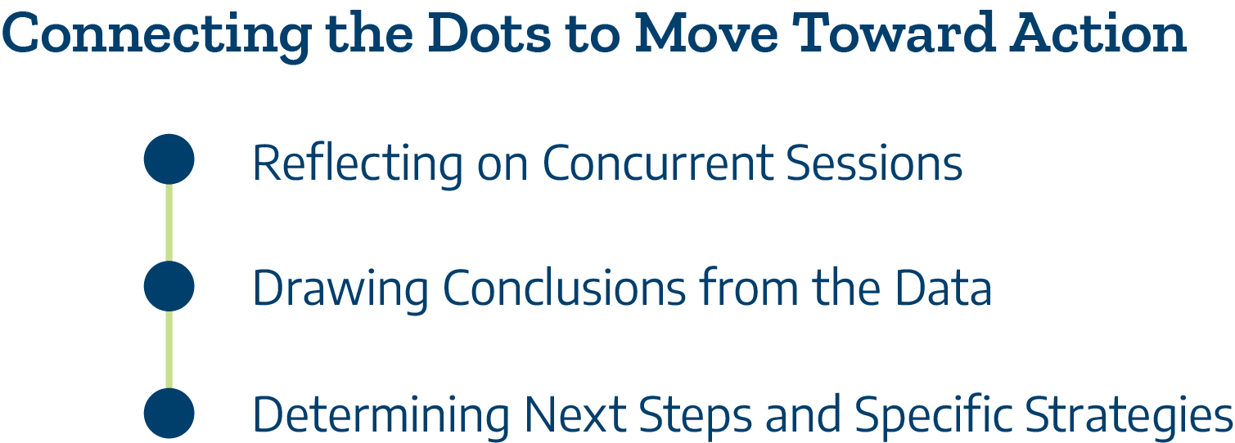

Students have experienced extreme loss, sometimes their own health, their own family members, job loss, pandemic learning loss, lack of access to housing and consistent food sources. This loss is so heavy that we can’t just solve it by building the right program. These are broader issues. We need bigger solutions. We need much bigger approaches than tweaking the curriculum or adding programs. It just seems bigger than that.
-Adapted from Chronicle of Higher Education, 2021

Concurrent Sessions
What did team members learn from the concurrent sessions that can be applied to leadership for transformation? (Add additional rows as needed to capture insights from each team member.)

Session | Key Takeaway(s)

Aligning Leadership and Strategies to Improve Student Completion and Transfer
During the institute, team members examined the college’s goals and transformational leadership capacity to implement Talent Strong Texas Pathways (Team Strategy Time #1) and credential completion and transfer outcomes for students (Team Strategy Time #2). Now, teams will synthesize these discussions to determine the specific strategies and actions necessary for leadership to engage the entire college community, including external partners, to improve the student experience.

Evidence-based Discussions to Promote Equitable Student Completion and Transfer
Question | Answer
How does the college leadership team utilize disaggregated data to understand barriers to equitable student completion and transfer success?

How often will the college leadership team inclusively engage stakeholders across the college in these evidence-informed, inquiry-based conversations?

What college-level policies expand the transfer pipeline and expedite completion?

What college-level policies restrict the transfer pipeline and deter completion?
Alignment to Promote Improved Student Completion and Transfer
Question | Answer
How does the college align human capital and financial resources to accomplish the completion and transfer goals of the college?

Preparation for Scaling Pathways
Question | Answer
How will the college leadership team lead the college in full scale implementation of Talent Strong Texas Pathways?
Where does the college have the most robust community college and employer partnerships?

How will the college leadership team replicate similar partnerships with other employers?

Please upload your completed team time document to the Document Center on the Event Page using the file name:
[Your college name]_TSTPI#1 Team Time 3.docx

Scan here!

