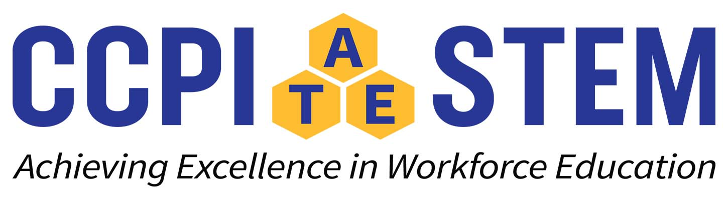
Upcoming Webcast Events
Visit Ccpi-stem.org for more information.

April 21, 2023: Community College and Industry Partnerships: A Strategic Workforce Collaboration

May 11, 2023: The League for Innovation in the Community College (League) and the Community College Presidents’ Initiative in STEM (CCPI-STEM) are excited to invite you to the virtual Community College Thought Leaders’ Dialogue for STEM Education and NSF ATE grant funding from 2:00 to 3:30 PM Eastern
Time RSVP by April 27

May 12, 2023: CCPI-STEM Fellows Program: A Unique Opportunity

