Leading to Scale Dual Credit Pathways: Data DEEP Dive
Texas Pathways Institute
Pre-Institute Session, April 12th, 2023
John Fink & Tatiana Velasco, CCRC; Lauren Schudde & Wonsun Ryu, UT-Austin

Bring a laptop and dive into your college’s dual credit data using a series of new Tableau dashboards developed by the Community College Research Center (CCRC) and UT-Austin describing dual credit access and outcomes among recent Texas high school graduates.

Session Goals:
- Participants will identify and apply insights from dual credit dashboards to inform improvement planning to further strengthen their college’s dual credit strategy
- “Beta-test” and provide input and suggestions for further refinement of the dashboards for future use among TX colleges and their K12 school partners

Link to College- and School-level Dashboard: https://tinyurl.com/CCRC-UT-DCDashboard-Beta

Statewide Results: https://tinyurl.com/CCRC-UT-DCDashboard-Statewide

The CCRC/UT dual credit dashboard draws on statewide, longitudinal, student-level data from the Texas Education Research Center (ERC). Per the requirements of the ERC, results with small cell sizes or otherwise identifiable combinations of released data have been suppressed for privacy (a list of masking condition and corresponding codes is included in the Table 2). As a result, some results may appear blank or otherwise are masked.

What students are included in this dashboard? This dashboard includes data on two cohorts of 9th grade students entering traditional Texas public high schools in fall 2015 and fall 2016 (e.g., the HS classes of 2019 and 2020). This analysis focused dual credit at traditional public high schools, meaning that we excluded Early College High Schools and P-TECHS. The data track students’ enrollment in Texas public community colleges or universities through their first year post-high school.

Getting Started

The dashboard is divided up into four tabs:

- Summary. Select your college and see an overview of results for your dual credit students in terms of access and participation in dual credit by student group, top dual credit course enrollments, and top college destinations and majors after high school.
  - Start by selecting your college and viewing results across “All HS Partners”
  - Switch between disaggregating by race/ethnicity, income, and gender
  - Compare your college to the state or your region overall in the upper-right panel
  - Switch to another “Outcome Type” (e.g., DC Post-HS Outcomes) to summarize different types of results

- College-HS Pair Table. View results specific to dual credit students from your high school partners, ranked by the number of dual credit students enrolled at your college.
  - Use this table to identify and prioritize high schools with substantial enrollments among lower-income students with potential for further growth of dual credit.

- DC Coursetaking. This tab shows information about dual credit students and their coursetaking patterns and outcomes for the selected college and high school pair.
  - View the mix of dual credit course location (e.g., at the college or high school) and modality (e.g., face-to-face or online) across all high school partners or for individual high school partners.
  - See how course pass rates (C or higher) differ by student group and course modality or location.
  - Compare across student groups the average number of credits attempted through dual credit, rate at which dual credit students complete 9 or more credits, and rate at which dual credit students complete college English or math while in high school.

- Post-HS Outcomes. This tab shows college enrollments among former dual credit students within one year of graduating high school.
  - See the rates of any college enrollment and enrollment back at your college after high school, disaggregated by student group
  - For former dual credit students who enrolled at any college, see disaggregated rates of college persistence in their first year after high school.
  - View the top colleges and major former dual credit students enrolled in during the first year after high school.

In the following, we present for each of these four tabs, numbered questions that correspond to sections of the given tab shown on the page following the questions.

Summary Tab – Dashboard Overview
Feedback Survey: https://tinyurl.com/ccrc-tpi-1

Access to Dual Credit
- Which groups of students by race, gender, and income have higher participation rates in DC? How many participate in CTE DC, and do the same gaps exists?
- How does DC participation compare when including AP/IB coursework?
- How do we compare to the state and our region on these measures of access?

Post-HS outcomes
- What colleges are our former DC students enrolling at after high school? How many return to our college?
- What are the top college majors among our former DC students who went to college after HS? What do we know about DC students’ aspirations and plans for college/career and programs of interest?

DC Courses Taken
- What are the top 10 DC course enrollments across all our high school partners? What are the top 10 DC courses for Black, Hispanic, and low-income students? What’s the potential of these courses to be strengthened as on-ramp into college programs? How well aligned are these courses to the colleges and programs students enroll in after high school.

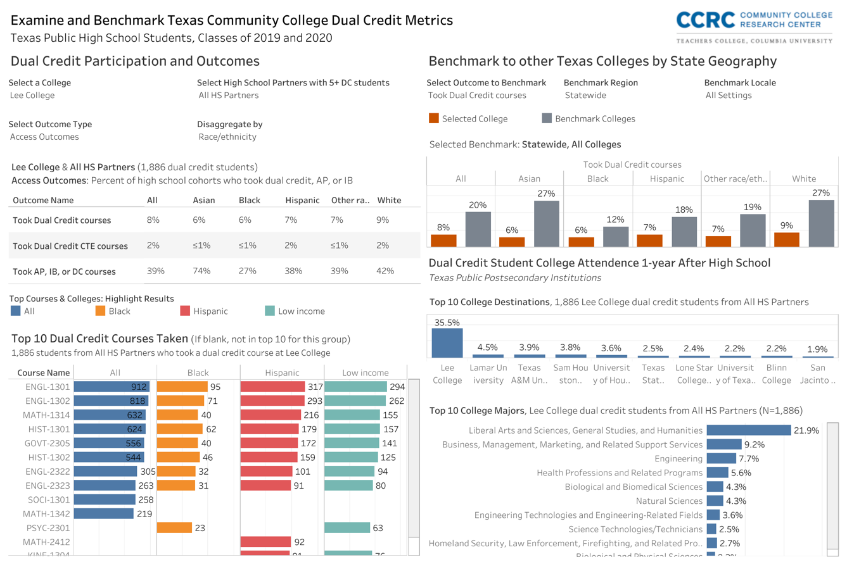
4
6
5
3
2
1
Notes & Key Takeaways: Summary Dashboard

College - High School Pair Tab
4-Question Feedback Survey: https://tinyurl.com/ccrc-tpi-1
Access Measures
- Which of our largest HS partners have the biggest gaps in access to dual credit for Black, Hispanic, and low-income students?
- Which high school partners do we have the most potential to grow DC enrollments among low-income students?
  - Which schools have larger enrollments of low-income students but low DC participation rates?

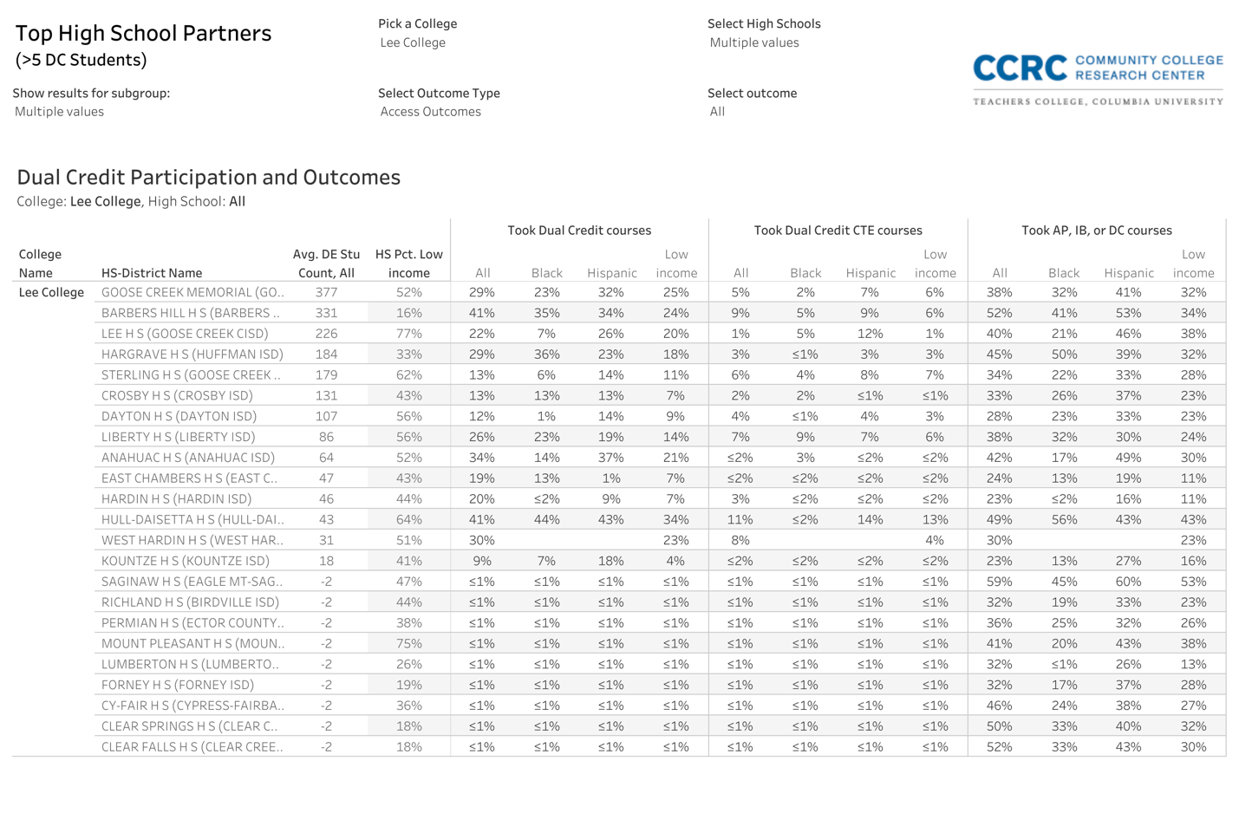
2
1

Notes & Key Takeaways: Access to Dual Credit by HS Partner

Dual Credit Coursetaking Tab
4-Question Feedback Survey: https://tinyurl.com/ccrc-tpi-2

Course Location & Modality
- What are the primary course location and delivery modalities for DC across our HS partners? How does this vary by student race, income, and gender? Which types of courses are Black, Hispanic, and low-income students overrepresented in?

DC Course Success & Momentum
- What are the success rates for DC students, and how does this vary by course location and modality? Which types of DC courses have the lowest success rates? Why might that be, and what other information do we need to better understand this?
- What are the success rates for students by race, income, and gender? Which groups need more support in these courses to be successful?
- On average how many credits do DC students attempt while in high school, and to what extent are students meeting key milestones like completing 9 or more college-level credits, completing college English, or completing college math through DC? What gaps exist?

DC Courses Taken
- What are the top 10 DC course enrollments across all our high school partners? What are the top 10 DC courses for Black, Hispanic, and low-income students? What’s the potential of these courses to be strengthened as on-ramp into college programs?
5
4
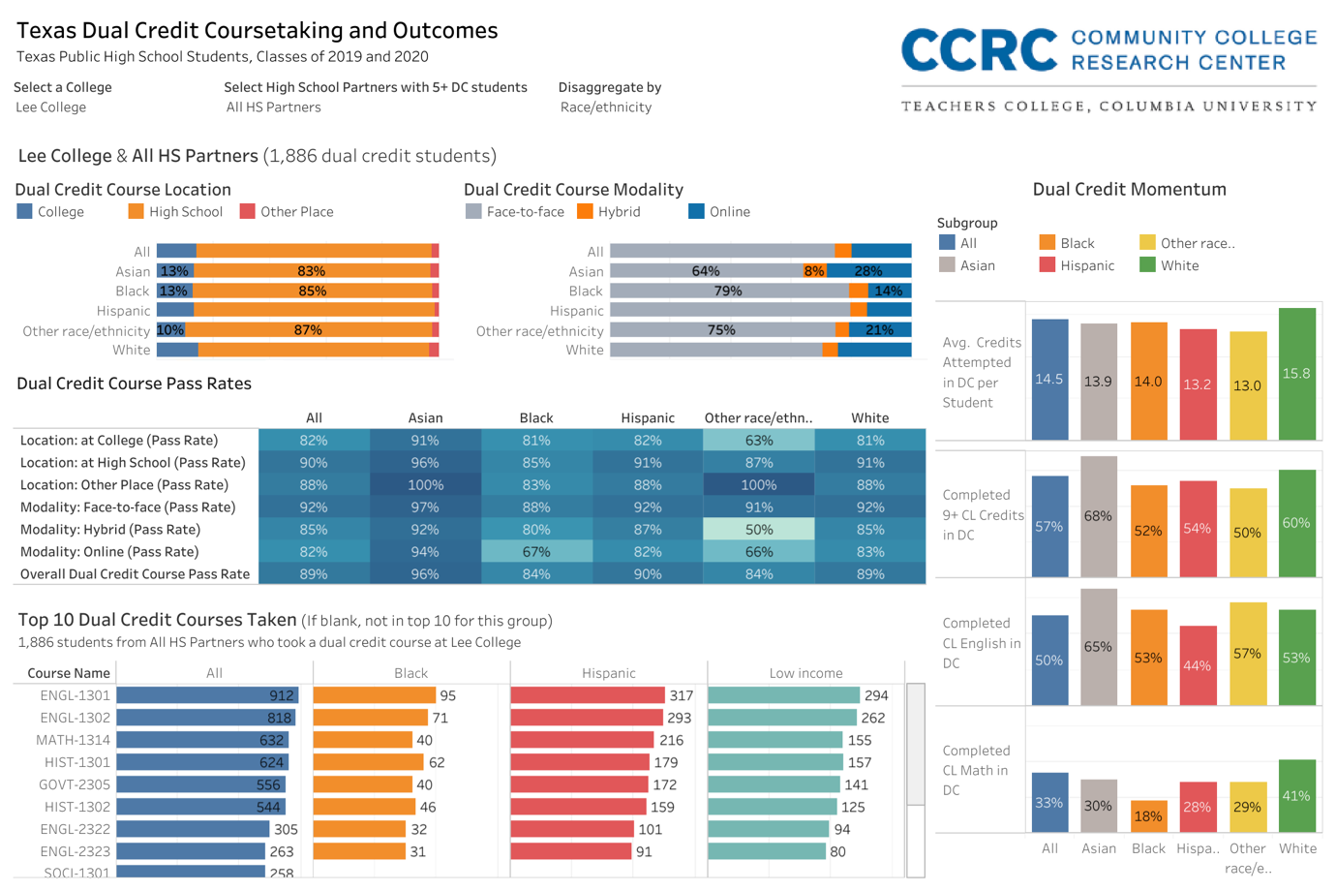
3
2
1

Notes & Key Takeaways: Dual Credit Coursetaking & Momentum

Post-HS Outcomes Tab
4-Question Feedback Survey: https://tinyurl.com/ccrc-tpi-3

- What percent of former DC students enrolled at any college within 1 year after high school? And what percent of former DC students reenrolled at our college after high school?
- Which groups of students by race, income, and gender have higher rates of college enrollment, and which groups are more likely to persist in college? Are there gaps by race, income, or gender in first-year college persistence for our former DC students?
- What are the other top colleges are our former DC students attending after high school? What college majors are our former DC students enrolling in after high school?
- How could we use this information to strengthen our DC offerings as on-ramps to programs of interest for students?
  - How could we work with faculty and others in our various program areas to strengthen recruitment of DC into our programs when they leave HS?
  - How can we help students who enroll in Liberal/General Studies choose and plan a path to more specific major fields?

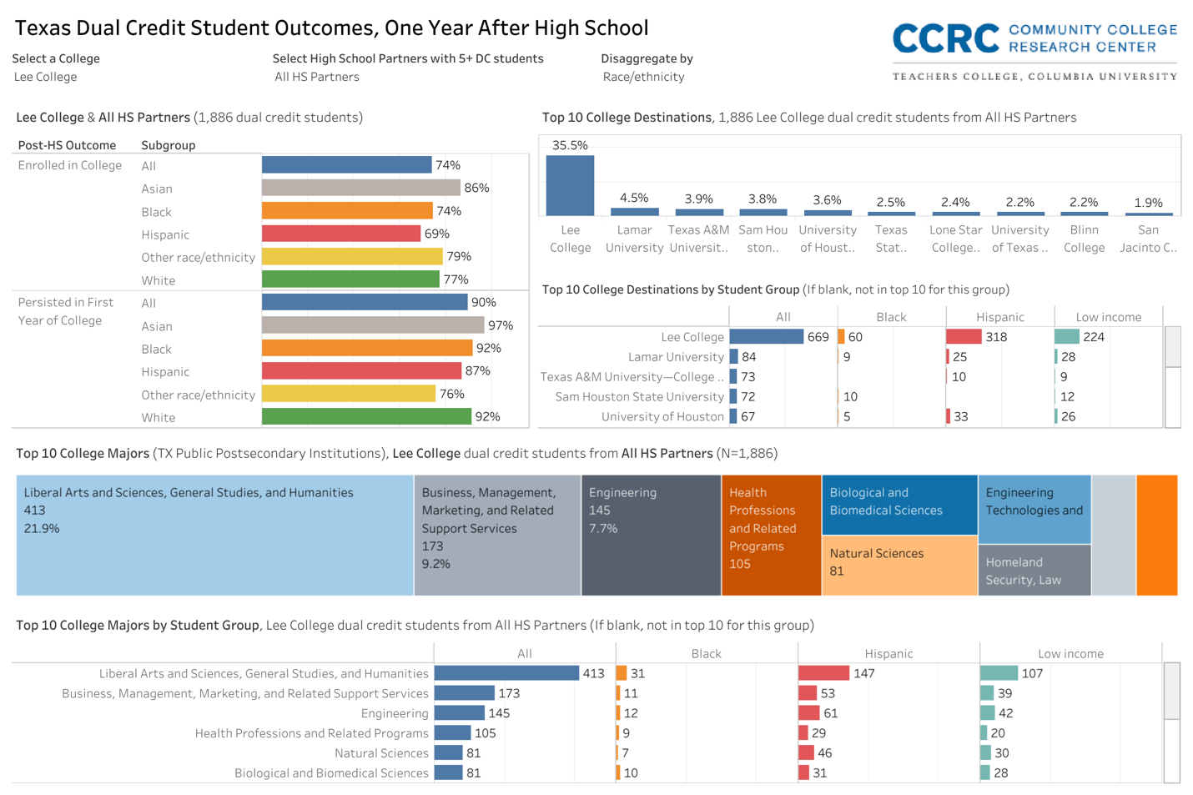
4
3
2
1
Notes & Key Takeaways: Post-High School College Enrollments and Outcomes

Table 1. Data Elements and Outcome Definitions

Data Element | Definition
High school student cohort | Number of students ever enrolled at the HS within 4 years from HS entrance (2015-2016 HS freshman cohort)
Dual Credit participation | Percent of students―in the HS cohort―who attempted any dual credit (DC) courses through the HS-CC pairing within 4 years from HS entrance
CTE Dual Credit participation | Percent of students―in the HS cohort―who attempted any CTE DC courses through the HS-CC pairing within 4 years from HS entrance
AP/IB/DC participation | Percent of students―in the HS cohort―who attempted any AP, IB, or DC courses through the HS-CC pairing within 4 years from HS entrance
Results disaggregated by student characteristics:
Gender | Student sex (male/female) as provided by TEA
Race/ethnicity | Student race or ethnicity as provided by TEA
Income | Students categorized as low-income if they were ever eligible for Free or Reduced Price Lunch, as provided by TEA
Among students who took DC courses via the high school-community college (HS-CC) pairing:
Pct. Of DC by Location | DC credits attempted at the college, high school, or another location (e.g., multi-institution teaching center) as a percent of DC credits attempted through the HS-CC pairing
Pct. Of DC by Modality | DC credits attempted face-to-face, online, or hybrid as a percent of DC credits attempted through the HS-CC pairing
DC Course Pass Rates | Percent of DC courses completed (Pass, C, or above) among DC courses attempted via the HS-CC pairing
Completed 9+ CL Credits in DC | Percent of high school students who took any DC who completed 9 or more college-level DC credits in the HS-CC pairing prior to HS graduation
Completed CL English in DC | Percent of high school students who took any DC who completed a college-level English DC course in the HS-CC pairing prior to HS graduation
Completed CL Math in DC | Percent of high school students who took any DC who completed a college-level math DC course in the HS-CC pairing prior to HS graduation
Avg. Credits Attempted in DC per Student | Average number of DC credits attempted via the HS-CC pairing per student in the HS-CC pairing
Attended any college post-HS | Percent of high school students who took any DC via the HS-CC pairing who enrolled at any postsecondary institution after HS by the end of the first academic year
Re-enrolled at DC college | Percent of high school students who took any DC via the HS-CC pairing who enrolled at the same DC college by the end of the first academic year after HS graduation
College persistence in first year | Percent of college-going high school students who took any DC via the HS-CC pairing who continued enrolling in through the end of the first academic year after HS graduation
Top College Destinations | Top colleges that high school students who took any DC via the HS-CC pairing enrolled at during the first academic year after HS graduation
Top College Majors | Top majors that high school students who took any DC via the HS-CC pairing enrolled in during the first academic year after HS graduation

Table 2. Masking Rules

Condition | Assigned Masking Values
 | Numerator | Denominator | Percent
Denominator is < 5 including 0 | -1 | -1 | -1
Numerator is < 5 including 0 | -2 | -2 | %
Percent is 100% or rounds to 100% (Rounding depends on the group size) | -3 | -3 | Top Code %
Percent is 0% or rounds to 0% (Rounding depends on the group size) | -4 | -4 | Bottom Code %
Percent is 100% or 0% and the group size is < 10 | -5 | -5 | -5
The difference between the numerator and the denominator is < 3 | -6 | -6 | %
Cell with possibility of reverse calculation of the original masked value | -7 | -7 | %
Any other cell with fewer than 5 students | -8 | -8 | %
Not applicable | -9 | -9 | -9

