Team Strategy Time #3: Cadre 3

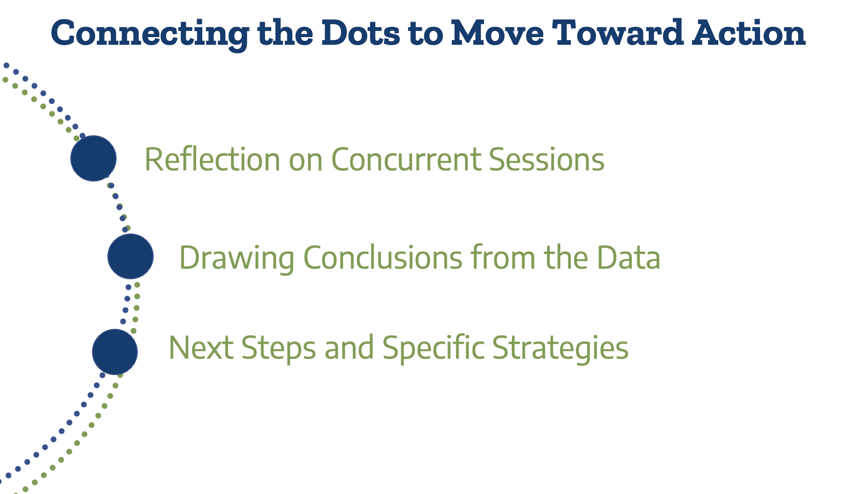

Concurrent Sessions
What did team members learn from the concurrent sessions that you can apply to the implementation and improvement of student learning? (Add additional rows as needed to capture insights from each team member.)

Session | Key Take-Away(s)

Aligning KPIs and Focus Group Data
Now that you have examined KPIs on the progress of your college in students completing courses (Team Strategy Time #1) and qualitative data to hear the student and faculty voices about the strengths and challenges at your college related to teaching and learning (Team Strategy Time #2), let’s pull it all together to examine next steps with specific strategies for improving the student experience that will lead to continued increases in KPIs across student groups and improved student learning.

Relating KPI and Focus Group Data: Review the KPI data that was insightful for your team. Review the key recommendations for the college that came from the focus groups.
Question | Answer
What strategies have faculty used in the classroom to improve student learning and course completion?

What strategies in use by faculty could have led to improved student equity in completion KPIs?

What strategies in use by faculty may be hindering progress in student learning outcomes?
How do these quantitative and qualitative data provide the college with areas of focus for improvements in teaching and learning within a Texas Pathways framework?
What strengths are seen in the quantitative and qualitative data that can be leveraged to better understand and improve student learning?

Preparing for Continuous Improvement
Question | Answer
How will you engage stakeholders across the college in discussing the quantitative and qualitative data about student learning?

How often do you need to have these evidence, inquiry-based conversations?

What digital student learning strategies did the college develop during COVID-19 that proved effective and that we want to continue?

How do ensure these strategies are scaled for access by all students?

Please upload your completed team time document to the Document Center on the Event Page using the file name: [Your college name]_TPI6Team Time 3.docx

