Team Strategy Time #2: Cadre 1+ and 1

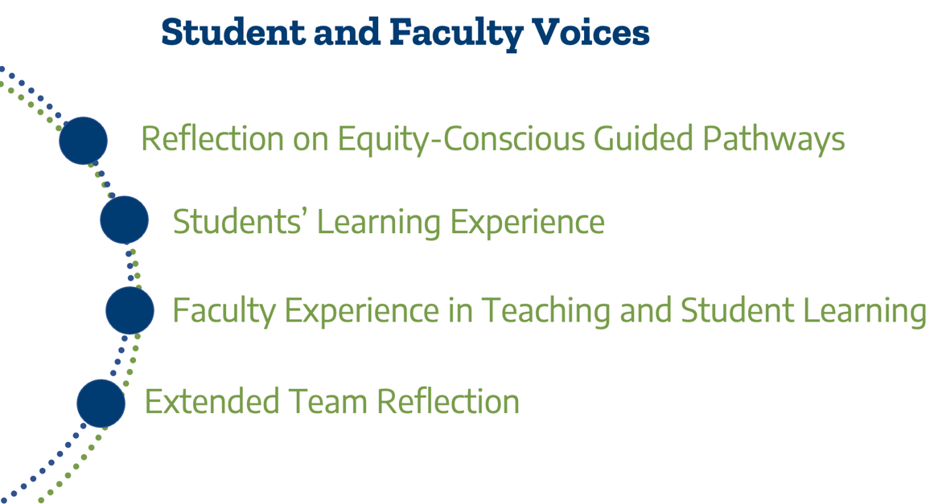

This Texas Pathways Institute focuses on the fourth pillar of the Texas Pathways strategy, Ensuring Students are Learning. The essential practices of this pillar include the following:
4(a). Program learning outcomes are aligned with the requirement for success in further education and employment outcomes targeted by each program.
4(b). Students have ample opportunity to apply and deepen knowledge and skills through projects, internships, co-ops, clinical placements, group projects outside of class, service learning, study abroad and other active learning activities that program faculty intentionally embed into coursework.
4(c). Faculty programs assess whether students are mastering learning outcomes and building skills across each program, in both arts and sciences and career/technical programs.
4(d). Results of learning outcomes assessment are used to improve teaching and learning through program review, professional development, and other intentional campus efforts.
4(e). The college helps students document their learning for employers and universities through portfolio and other means beyond transcript.
4(f). The college assesses effectiveness of educational practice (e.g., using CCSSE or SENSE, etc.) and uses the results to create targeted professional development.

Day 1 Plenary Reflection: Designing Equity-Conscious Guided Pathways to Ensure Students are Learning
Summarize your team’s top three takeaways from Dr. Tia Brown McNair’s presentation that are most significant for your college in Ensuring Students Are Learning.

1.

2.

3.

Student Focus Groups Reflection
Your college team had the opportunity to hear from students as part of the advance work for this Texas Pathways Institute. Based on the analysis in your student focus group report, answer the following questions.

- What does the college do well in teaching and learning according to the students participating in your focus groups? What did students identify as effective practices and policies at your college that support student learning?

- What did students identify as areas for improvement for the college to better support student learning?

- What lessons from the Texas Pathways Institute’s plenary session can you apply to address areas for improvement identified by students?

- Discuss the key recommendations identified in your focus group report. Are there recommendations for communication, instructional strategies, academic support processes, and/or policies?

- How might the college expand the use of qualitative data about the student experience to inform change? Which types of students do you need to hear from?

Faculty Focus Groups Reflection
Your college team had the opportunity to hear from faculty as part of the advance work for this Texas Pathways Institute. Based on the analysis in your faculty focus group report/s, answer the following questions

How did the faculty describe effective teaching?

- What active learning and cultural awareness strategies are faculty utilizing in their classrooms?

- How do faculty build relationships with students? Build peer to peer relationships?

- How do faculty assess that students are learning the identified learning outcomes?

- What recommendations did the faculty provide to improve student learning and professional development at the college?

Extended Team Reflection

- Is there a broad understanding among people across the campus(es) about the areas in which the college excels in ensuring students are learning?
- How does the college communicate about effective practices that support student learning to leaders, faculty, staff, students, and others across campus(es)?

- What is the process for continuous improvement of the assessment of student learning? How might it be improved?

- How often does the college celebrate the progress of improved student learning?

Please upload your completed team time document to the Document Center on the Event Page using the file name: [Your college name]_TPI6Team Time 2.docx

