Team Strategy Time #1: Cadre 2

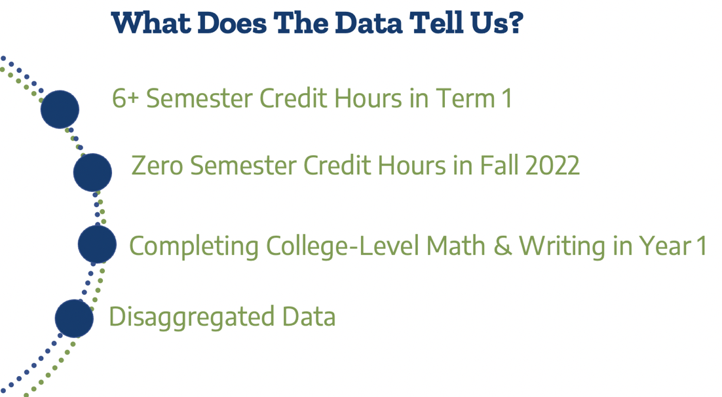

What does the data show about ensuring teaching and learning?
This Texas Pathways Institute focuses on the fourth pillar of the Texas Pathways strategy, Ensuring Students are Learning.

The Texas Success Center uses eight Early Momentum Metrics (EMMs) from the set of Key Performance Indicators (KPIs) to evaluate the impact of Texas Pathways for first-time-in-college students. Between 2015 and 2020, there has been statewide improvement across seven of the eight EMMs:
- Completing 6 or more college-level credits in the first term
- Completing 15 or more college-level credits in the first year
- Completing 30 or more college-level credits in the first year
- Completing college-level math in the first year
- Completing college-level reading-intensive course in the first year
- Completing college-level writing-intensive course in the first year
- Completing college-level math, reading, and writing in the first year

At the Texas Pathways Institute #5 in April 2022, we explored several KPIs related to Keeping Students on their Pathway, including persistence, 15 and 30 college-level credits in the first year, and completing college-level math and writing-intensive course in the first year.

In this institute, we will study certain KPIs to evaluate the impact of Texas Pathways as we seek to examine Teaching and Learning in the Texas Pathways Framework.
- Completing 6 or more college-level credits in the first term
- Completing college-level math in the first year
- Completing college-level writing-intensive course in the first year

We will also examine the completion of zero semester credit hours (0 SCH) in the Fall 2021 term that you collected in your advance work.

First you will examine the proportion of students completing 6 or more college-level semester credit hours (6+ SCH) in the first semester using the KPI dashboard: 6+ SCH.
- Simplify the view to look at your college with the “Institution” filter at the top.
  - Unclick “All,”
  - Click your college’s name, and
  - Click “State” to compare your college to the state on the same dashboard.
- You will use the filters on the left side to examine several questions. Some filters will remain the same. Set the filters on the right to:
  - Percentage of FTIC Students
  - Chart Type: Stacked Chart (recommended)
    - There is also a line graph or table option for use if you prefer.
- Adjust the filters to answer the questions. Use the last column to record your answers.

Dashboard Filters | Questions | Answers:  6+ Credits (Fall 2015) | Answers:  6+ Credits (Fall 2020)
Student Characteristic:  Total | What was the total percentage of students completing 6+ SCH in term 1 at your college in Fall 2015 and Fall 2020? | College | College
 |  | State | State
 | How does your college compare to the state’s 6+ SCH completion rate in Fall 2015 and Fall 2020?
Student Characteristic:  Race/ Ethnicity | What was the overall proportion of students completing 6+ SCH in term 1 for each racial/ethnic category at your college in Fall 2015 and Fall 2020? | African American | African American
 |  | Hispanic | Hispanic
 |  | Other Race/Ethnicity | Other Race/Ethnicity
 |  | White | White
Student Characteristic:  Pell Status | What was the overall proportion of students completing 6+ SCH in term 1 by Pell status at your college in Fall 2015 and Fall 2020? | Received Pell | Received Pell
 |  | Did Not Receive Pell | Did Not Receive Pell
Student  Characteristic:  Preparedness  Status | What was the overall proportion of students completing 6+ SCH in term 1 by prepared/underprepared designation at your college in Fall 2015 and Fall 2020? | Underprepared | Underprepared
 |  | Prepared | Prepared

Please answer the questions utilizing the advance work on students completing 0 SCH at your college in fall of 2021.

Dashboard Filters | Questions | Answers: 0 SCH (Fall 2021)
Student Characteristic:  Total | What was the total percentage of students completing 0 SCH at your college in Fall 2021? | College
Student  Characteristic:  Gender | What was the overall proportion of students completing 0 SCH by gender in Fall 2021? | Female
 |  | Male
Student Characteristic:  Race/Ethnicity | What was the overall proportion of students completing 0 SCH for each racial/ethnic category at your college in Fall 2021? | African American
 |  | Hispanic
 |  | Other Race/Ethnicity
 |  | White

Analysis: Use the insights from above to consider the following questions.
Questions | Answers: Reflection on 6+ and 0 SCHs
What data points most surprised you in the completion of 6+ SCH in term 1 data? In the 0 SCH?
Is there overall improvement in students completing 6+ SCH in term 1 between 2015-2020?

Is the growth for African American and Hispanic students outpacing White students (i.e., leading to reduction in equity gaps)?
Based on these data, what concerns do you have about equity among student groups in completion of 6+ SCH in the term 1 and those completing 0 SCH in Fall 2021?
How often do you evaluate completing 6+ SCH in term 1 disaggregated by race/ethnicity, gender, full/part-time status, Pell status, and prepared designation to understand areas of growth and examine equity implications?

Who on your campus is having those discussions?
How often do you evaluate the proportion of students who complete 0 SCH in the fall term?

What discussions do you or can you as faculty and academic leaders have on this data point?
How does this data influence your discussion on effective teaching and learning at the college?
For the Math and Writing-Intensive Course Completion, you are welcome to import the data from the TPI5 institute team time 1 document. We will explore different questions in the analysis.

Research tells us that first-year completion of a college-level mathematics course aligned with student program pathways is the strongest course predictor of college credential completion (Charles A. Dana Center, Community College Research Center, Georgetown Center for Education and the Workforce).

Next, you will examine the proportion of students completing college-level math in year 1 and the proportion of students completing college-level writing in year 1 using:
- The KPI dashboard: Math
- The KPI dashboard: Writing
- Simplify the view to look at your college with the ‘Institution’ filter at the top.
  - Unclick “All,”
  - Click your college name, and
  - Click “State” to compare your college to the state on the same dashboard.
- You will use the filters on the left side to examine several questions. Some filters will remain the same. Set the filters on the right to:
  - Percentage of FTIC Students
  - Chart Type: Stacked Chart (recommended)
    - There is also a line graph or table option for use if you prefer.
- Adjust the filters to answer the questions. Use the last column to record your answers.

Dashboard Filters | Questions | Answers:  Math and Writing  (Fall 2015) | Answers:  Math and Writing  (Fall 2020)
Student Characteristic:  Total | What was the total percentage of students completing math in year 1 at your college in Fall 2015 and Fall 2020? | College: Math | College: Math
 |  | State: Math | State: Math
 | Completing writing in year 1 in Fall 2015 and Fall 2020? | College: Writing | College: Writing
 |  | State: Writing | State: Writing
 | How does your college compare to the state in completing math in year 1 in Fall 2015 and Fall 2020?
 | Completing writing in year 1 in Fall 2015 and Fall 2020?
Student Characteristic:  Race/ Ethnicity | What was the overall proportion of students completing math in year 1 for each racial/ethnic category at your college in Fall 2015 and Fall 2020? | African American | African American
 |  | Hispanic | Hispanic
 |  | Other Race/Ethnicity | Other Race/Ethnicity
 |  | White | White
 | Completing writing in year 1 in Fall 2015 and Fall 2020? | African American | African American
 |  | Hispanic | Hispanic
 |  | Other Race/Ethnicity | Other Race/Ethnicity
 |  | White | White
Student Characteristic:  Preparedness Status | What was the overall proportion of students completing math in year 1 by preparedness status at your college in Fall 2015 and Fall 2020? | Underprepared | Underprepared
 |  | Prepared | Prepared
 | Completing writing in year 1 in Fall 2015 and Fall 2020? | Underprepared | Underprepared
 |  | Prepared | Prepared
Student Characteristic:  Pell Status | What was the overall proportion of students completing math in year 1 by Pell status at your college in Fall 2015 and Fall 2020? | Received Pell | Received Pell
 |  | Did Not Receive Pell | Did Not Receive Pell
 | Completing writing in year 1 in Fall 2015 and Fall 2020? | Received Pell | Received Pell
 |  | Did Not Receive Pell | Did Not Receive Pell

Questions | Answers: Reflection on Math and Writing
What data points surprised you?

Is there overall improvement in students completing college-level math and writing in year 1 from 2015-2020 at your college?

Is the growth for African American and Hispanic students outpacing White students (i.e., leading to reduction in equity gaps)?
For math?

For writing?

What impact has corequisite implementation had on completing college-level math and writing in year 1 for students who come to the college and are designated underprepared? Do you see this impact in the KPI outcomes?

Is the growth for students designated as underprepared outpacing those who are prepared (i.e., leading to reduction in equity gaps)?

Based on these data, what concerns do you have about equity among student groups in completion of college-level math and writing in year 1?

How often does the college evaluate completion of college-level math, writing, and reading in year 1 disaggregated by race/ethnicity, preparedness, and Pell status to understand areas of growth in student learning and equity implications?

Who on your college is having those discussions? Who else at your college needs to be included in those discussions?

How does this data impact your discussion on teaching and learning as it relates to corequisite redesign and pedagogy in the classroom?

Using the answers from all sections above, discuss the following summary questions.
Questions | Answers: Observation of Trends
What trends do you see across the KPIs by student characteristics?

Based on these trends, what concerns do you have about equity among student groups in measures related to students successfully completing courses and earning credit?

How does your college use KPI data to evaluate institutional reforms in teaching and learning?

What types of institutional data do faculty have access to that can guide continuous improvement efforts for the courses they teach?

What additional data elements should be shared with faculty to deepen conversations which can inform course design and teaching strategies that lead to equitable learning outcomes?
Does the college prioritize equity in student learning outcomes?

If so, what strategies are currently used to communicate to the college community and students that equity in student learning outcomes is a priority?

Is this priority communicated through:
- Strategic plans?
- Convocations, professional/staff development, and commencements?
- Departmental review of data and goal setting?
- Marketing and recruitment, K-12 connections, and community & adult outreach?
- What additional communications associated with equity in student outcomes would be valuable?

If not, how can college leaders use data to make the case that equity in student outcomes should be a priority of the college?

Please have team members decide which concurrent sessions they will attend. In Team Strategy Time #3 we will take the first 15 minutes to report back on key learnings from the concurrent sessions.

Please upload your completed team time document to the Document Center on the Event Page using the file name: [Your college name]_TPI6Team Time 1.docx

