Today’s Agenda:
- A History of Our Work via T.L.L. Temple Foundation Grants
- Our Partnerships
- What Pathways Means to Lee College
- Course Alignments and Slicks
- Walkabout
- Build Your Own Alignments
Our Team:
- Dr. Laura Lane-Worley, Director, Lee College Education Center, South Liberty County, Lee College
llaneworley@lee.edu
- Dr. Marissa Moreno, Executive Director, School and College Partnerships, Lee College
mmoreno@lee.edu
- Ms. Courtney Byers, Interim Director, Dual Credit, Lee College
cbyers@lee.edu
- Ms. Nicole Tunmire, Instructional Designer, Lee College
ntunmire@lee.edu

Information Links
Lee College Pathways  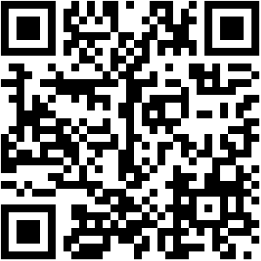 | Lee College Dual Credit Endorsements to Pathways  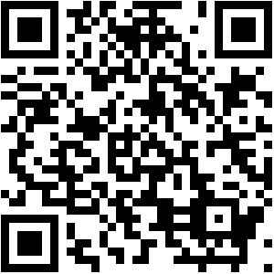

Activity Instructions:
Complete a template aligning a high school endorsement to a college pathway.
- Select either an academic or technical program to align.
- For an academic program focus on core completion. Select the most appropriate courses in each component area. Remember to provide the suggested sequence for course.
- For a technical program, identify the stackable credential (certificate of completion) to be paired with additional courses for an AAS degree. List the suggested course sequence and additional courses required. Remember to include notes about industry certifications and/or Licensure and specifications for student populations.

Suggested Sequence
Component Area | Approved Core Courses | Credit Hours
Communication

Mathematics

Life & Physical Sciences

Language, Philosophy, & Culture

Creative Arts

American History

Government/Political Sciences

Social & Behavioral Sciences

Oral Communication

Institutional Requirement/Component Area Option

Additional Courses
Certificate of Completion
AAS Degree

Suggested Course Sequence
“Course Availability varies by high school and district”
Course | College Course Title
Associate of Applied Science
Students need to complete the # additional courses listed below to graduate with an AAS in
Notes about Industry Certifications and/or Licensure

Note for non-high school students
Note for Current High School Students and contact information

