Handout: Engaging Gen Z

"Engaging Gen Z” is presented by the Center for Excellence in Teaching and Learning and Educational Partnerships.

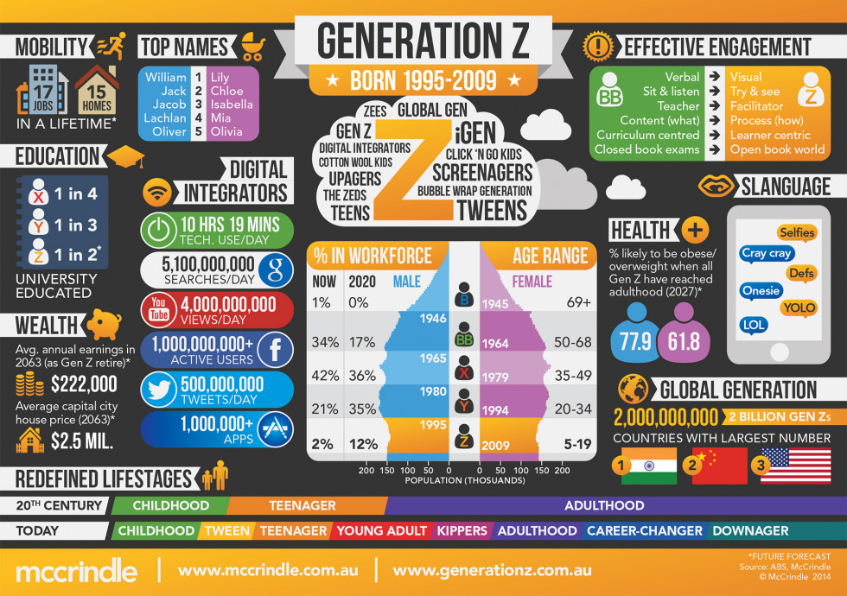

Gen Z Historic Timeline
- Lived through the 9/11 attacks.
- Witnessed the 2008 housing market crash.
- Grew up in a world where your calendar, video games, emails and GPS navigation can be accessed on a single device.
- Access the world's issues through technological devices.

About Gen Z
- Gen Z is a third of the U.S. population and the most racially diverse generation to date.
- 70% of Gen Z participants self-reported being motivated by not letting others down.
- Self-reported personal characteristics include loyalty, compassion and thoughtfulness.

Engagement Strategy 1: Leveraging Technology
- Gen Z grew up with access to the internet and other advanced technology tools; lengthy lectures aren’t effective (Swanger, 2018).
- Educators should embrace technology and find innovative ways to integrate it into their pedagogical practices (Davidson, 2017).
- Activity: Smartphone Triva — Students work in groups using their cell phones to conduct credible research.
- Activity: Group PSA Project — Students design a 6-8-minute video project addressing a community issue.

Engagement Strategy 2: Experiential Learning Activities
- Seemiller and Grace (2016) found Gen Z students most frequently enjoy experiential and logic-based approaches to learning.
- Experiential and logic-based approaches allow students to learn though trial and error and hands-on application.
- Activity: Infomercials — Students create 2-3-minute infomercials to sell a product.
- Activity: Exit Tickets— Students write out one thing they don't understand, want to discuss further or disagree with.

Engagement Strategy 3: Addressing Cultural Diversity
- Culturally responsive educators unlock hidden potential within their students by combating underachievement gaps.
- Culturally responsive educators build bridges between students' realities and lived experiences within the curriculum (newamerica.org).
- Strategy: Ensure instructional resources mirror the diverse student population you teach.
- Strategy: Use culturally sensitive language when teaching and facilitating learning.

Engagement Strategy 4: Student Retention
- Davidson (2017) noted that community colleges are unique institutions with open enrollment policies; therefore, faculty and institutional leaders should practice flexible approaches to meet students' needs.
- Gen Z students want an inclusive and affirming environment.
- Strategy: Implement a class buddy system and/or small collaborative accountability groups.
- Strategy: Stop before you drop and let's chat.

Learn More

Articles
- Twenge, J.M. (2017). iGen: Why Today's Super-Connected Kids Are Growing Up Less Rebellious, More Tolerant, Less Happy--and Completely Unprepared for Adulthood--and What That Means for the Rest of Us.
- Swanger, D. (2018). The Future of Higher Education in the U.S.: Issues Facing Colleges and their Impacts on Campus. Pages 20-23.

Web Resources
- Dimock, M. (2019). Defining Generations: Where Millennials End and Generation Z Begins.

Books
- Seemiller, C. & Grace, M. (2016). Generation Z Goes to College
- Davidson, C.N. (2017). The New Education: How to Revolutionize the University to Prepare Students for a World in Flux

TED Talks
- Seemiller, C. (2017). Gen Z: Making a Difference Their Way.
- Shaifer, J. (2018). How To Speak "Generation Z."

