Team Strategy Time #4: Cadre #3
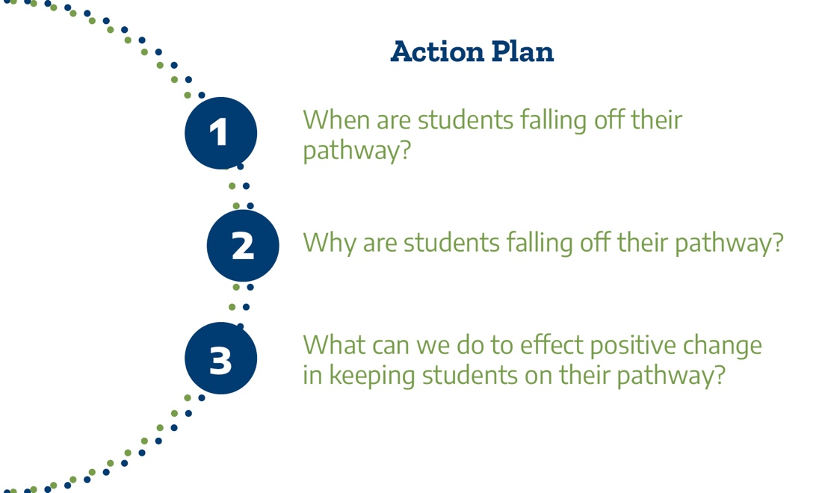

Action Planning for Transformational Change

At this point, your team has reviewed and discussed disaggregated KPIs for student persistence, completion of 15 SCH and 30 SCH in Year 1, and completion of college-level math and writing in Year 1. Your team has reviewed and discussed what the students at your college say about the strengths and challenges of Keeping on Their Pathway and the effectiveness of various student supports on their pathway journey. This session is an opportunity for the team to reflect on its learning, think through options for the college’s strategic approach to designing and implementing strategies and establish new or refined priorities for the work on campus. The college team should discuss next steps: whom to involve, how to communicate findings and broaden engagement on campus, and how, when, and by whom follow-up steps will be taken.

Identify 2 to 3 goals for improving your students’ experiences associated with Keeping Students on Their Pathway, regardless of the pathway at the college, especially focusing on closing opportunity and achievement gaps. Articulate these goals in your TSC action plan spreadsheet that has the goals from Pathways Institutes 2, 3, and 4.

Upload your completed Action Plan document to the Document Center on the Event Page using the file name: [Your college name]_TPI5 Action Plan.docx. Please submit your action plan by May 1, 2022.

