Team Strategy Time #1: Cadre #2

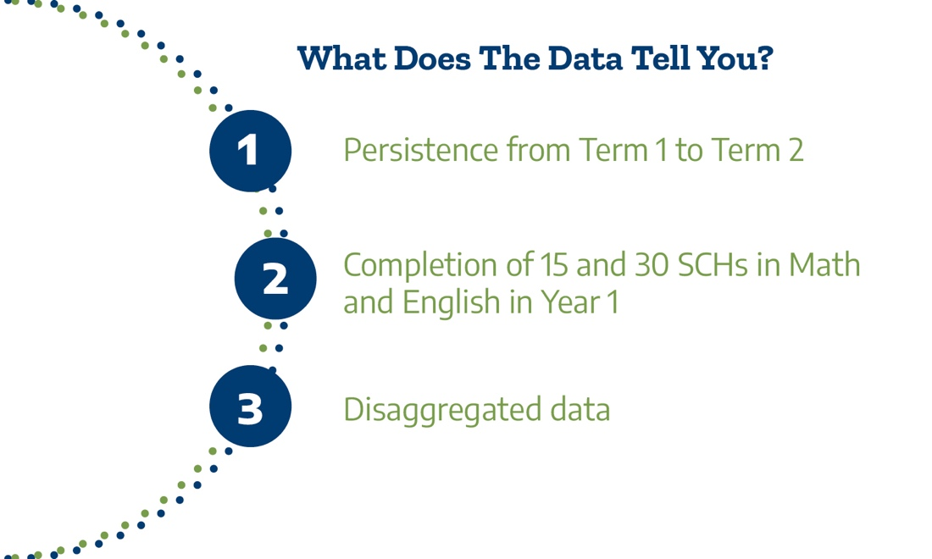

What does the data show about keeping students on their pathway?

The Texas Success Center uses eight Early Momentum Metrics (EMMs) from the set of Key Performance Indicators (KPIs) to evaluate the impact of Texas Pathways. Between 2015 and 2020, there has been statewide improvement across seven of the eight EMMs:
- Completing 6 or more college-level credits in the first term
- Completing 15 or more college-level credits in the first year
- Completing 30 or more college-level credits in the first year
- Completing college-level math in the first year
- Completing college-level reading-intensive course in the first year
- Completing college-level writing-intensive course in the first year
- Completing college-level math, reading and writing in the first year
The only early momentum metric that has not shown significant improvement across Texas community colleges is persistence from term 1 to term 2. Therefore, to start, you will examine persistence from term 1 to term 2 using the KPI dashboard
- Simplify the view to look at your college with the Institution filter labeled “Name” at the top.
  - Unclick “All,”
  - Click your college’s name, and
  - Click “State” to compare your college to the state on the same dashboard.
- You will use the filters on the left side to examine several questions. Some filters will remain the same. Set the filters on the right to:
  - Percentage of FTIC Students
  - Chart Type: Stacked Chart recommended. (There is also a line graph or table option for use if you prefer.)

Adjust the filters to answer the questions. Use the last column to record your answers.

Dashboard Filters | Questions | Answers
Student Characteristic:  Total | What was the total percentage of students progressing from term 1 to term 2 at your college in 2020?  How did your college compare to the state persistence rate in 2020? | College  State
Student Characteristic:  Race/Ethnicity | What was the overall proportion of students persisting from term 1 to term 2 for each racial/ethnic category at your college in 2020? | Black or African American  Other  Hispanic or Latino  White
Student Characteristic:  Pell Status | What was the overall proportion of students persisting from term 1 to term 2 by Pell status at your college in 2020? | Pell  Non-Pell

Analysis: Use the insights from above to consider the following questions.

Questions | Answers
Is there overall improvement in persistence rates from 2013-2020 at your college?

Based on these data, what concerns do you have about equity among student groups in persistence from term 1 to term 2?

How often do you evaluate persistence rates disaggregated by race/ethnicity and Pell status to understand areas of growth and examine equity implications? Who are on your campus is having those discussions?

Next, you will examine the proportion of students completing 15 semester-credit hours (SCH) in Year 1 and the proportion of students completing 30 SCH in Year 1 using:
- The 15-credit KPI dashboard
- The 30-credit KPI dashboard
- Simplify the view to look at your college with the ‘Institution’ filter at the top.
  - Unclick “All,”
  - Click your college’s name, and
  - Click “State” to compare your college to the state on the same dashboard.
- You will use the filters on the left side to examine several questions. Some filters will remain the same. Set the filters on the right to:
  - Percentage of FTIC Students
  - Chart Type: Stacked Chart recommended. (There is also a line graph or table option for use if you prefer.)
- Adjust the filters to answer the questions. Use the last column to record your answers.

Dashboard Filters | Questions | Answers
Student Characteristic:  Total | What was the total percentage of students completing 15 SCH in Year 1 at your college in 2020?  Completing 30 SCH in Year 1 in 2020?  How does your college compare to the state’s 15 SCH completion rate in 2020?  The state’s 30 SCH completion rate in 2020? | 15 SCH | 30 SCH
 |  | College | College
 |  | State | State
Student Characteristic:  Race/Ethnicity | What was the overall proportion of students completing 15 SCH in Year 1 for each racial/ethnic category at your college in 2020?  Completing 30 SCH in Year 1 in 2020? | 15 SCH 30 SCH  Black/African American  Other  Hispanic/Latino  White  Black/African American
Student Characteristic:  Pell Status | What was the overall proportion of students completing 15 SCH in Year 1 by Pell status at your college in 2020?  Completing 30 SCH in Year 1 in 2020? | 15 SCH 30 SCH  Pell  Non-Pell

Questions | Answers
Is there overall improvement in students completing 15 SCH and 30 SCH in Year 1 from 2013-2020?
Based on these data, what concerns do you have about equity among student groups in completion of 15 SCH or 30 SCH in Year 1?
How often do you evaluate completing 15 SCH and 30 SCH in Year 1 disaggregated by race/ethnicity and Pell status to understand areas of growth and examine equity implications? Who on your campus is having those discussions?

Research tells us that first-year completion of a college-level mathematics course aligned with student program pathways is the strongest course predictor of college credential completion (Charles A. Dana Center, Community College Research Center, Georgetown Center for Education and the Workforce).

Next, you will examine the proportion of students completing college-level math in Year 1 and the proportion of students completing college-level writing in Year 1 using:
- The math KPI dashboard
- The writing KPI dashboard
- Simplify the view to look at your college with the ‘Institution’ filter at the top.
  - Unclick “All,”
  - Click your college name, and
  - Click “State” to compare your college to the state on the same dashboard.
- You will use the filters on the left side to examine several questions. Some filters will remain the same. Set the filters on the right to:
  - Percentage of FTIC Students
  - Chart Type: Stacked Chart recommended. (There is also a line graph or table option for use if you prefer.)
- Adjust the filters to answer the questions. Use the last column to record your answers.

Dashboard Filters | Questions | Answers
Student Characteristic:  Total | What was the total percentage of students completing math in Year 1 at your college in 2020?  Completing writing in Year 1 in 2020?  How does your college compare to the state in completing math in Year 1 in 2020?  Completing writing in Year 1 in 2020? | Math | Writing
 |  | College | College
 |  | State | State
Student Characteristic:  Race/Ethnicity | What was the overall proportion of students completing math in Year 1 for each racial/ethnic category at your college in 2020?  Completing writing in Year 1 in 2020? | Math Writing  Black/African American  Other  Hispanic/Latino  White
Student Characteristic:  Underprepared/ Prepared | What was the overall proportion of students completing math in Year 1 by prepared/ underprepared designated status at your college in 2020?  Completing writing in Year 1 in 2020? | Math Writing  Prepared  Underprepared
Student Characteristic:  Pell Status | What was the overall proportion of students completing Math in Year 1 by Pell status at your college in 2020?  Completing writing in Year 1 in 2020? | Math Writing  Pell  Non-Pell

Questions | Answers
Is there overall improvement in students completing college-level math and writing in Year 1 from 2013-2020 at your college?
What impact has co-requisite implementation had on completing college level math and writing in Year 1 for students who come to the college and are designated underprepared?
Based on these data, what concerns do you have about equity among student groups in completion of college-level math and writing in Year 1?
How often do you evaluate completion of college-level math and writing in Year 1 disaggregated by race/ethnicity, preparedness, and Pell status to understand areas of growth and equity implications? Who on your campus is having those discussions?

Summary questions: Using the answers from each section above, discuss the following summary questions.

Questions | Answers
What trends do you see across the KPIs by student characteristics?
Based on these trends, what concerns do you have about equity among student groups in measures related to keeping students on a pathway?
How does your college use KPI data to evaluate institutional reforms for keeping students on their pathway?
What strategies are currently used to communicate to the college community and students that equity in outcomes associated with keeping students on a path are a priority to the college?

Is this priority communicated through convocations, professional and staff development, marketing, and departmental review of data and goal setting?

What additional communications associated with equity in student outcomes would be valuable?

Please upload your completed team time document to the Document Center on the Event Page using the file name: [Your college name]_TPI5Team Time 1.docx

