Team Strategy Time #2: Cadre 1+ and 1

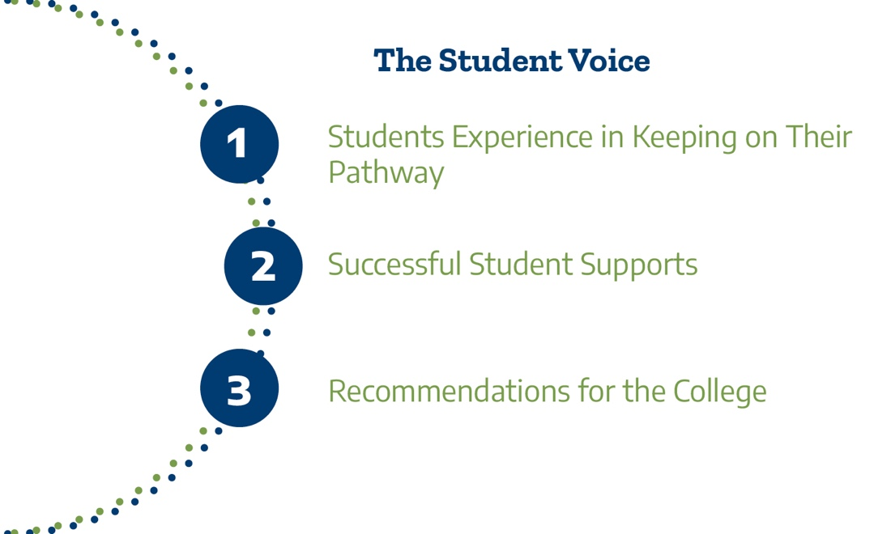

This Texas Pathways Institute focuses on the third pillar of the Texas Pathways strategy, Keeping Students on Their Pathway. which outlines the essential practices of this pillar.

Day 1 Plenary Reflection: Understanding and addressing student basic needs
Summarize your team’s top three takeaways from Dr. Goldrick-Rab’s presentation that are most significant for your college in Keeping Students on Their Pathway.

1.

2.

3.

Day 2 Plenary Reflection: What the Student Voice can tell us
Reflecting on Drs. Garcia and Garza’s presentation on centering students’ voices, summarize three messages that are most significant for your college in Keeping Students on Their Pathway.

1.

2.

3.

Current Practices Reflection
Advising Practices and Training
- How are advisors and students alerted when students are at risk of falling off their program pathway? What policies and supports are in place to intervene in ways that help students get back on track?
- How does the college support advisors/case managers/college navigators to incorporate engaging, proactive, and culturally-relevant advising practices to better support first-generation, minoritized, and low-income students’ success in their programs?

Student Supports
- How does the college integrate academic, basic needs, and student support services into program pathways so that supports are inescapable, and therefore less stigmatized?

- How does the college ensure that students' financial ecosystem needs (e.g., nutrition, transportation, childcare, public benefits, emergency assistance) are being met so they can make progress toward program completion?

Student Focus Groups Reflection
Your college team had the opportunity to hear from students as part of the advance work for this Texas Pathways Institute. Based on the analysis in your student focus group report, answer the following questions.

- What does the college do well in keeping students on their program pathway according to the students participating in your focus groups? What did students identify as effective practices and policies at your college that support students in staying on their path? (Be sure to review the two objective areas you selected as well as the overall college objective.)

- Is there a broad understanding among people across the campus(es) about the areas in which the college excels in supporting students to stay on their pathway? How does the college communicate about effective practices and policies that support students keeping on their pathway to leaders, faculty, staff, students, and others across campus(es)?

- How often does the college celebrate the progress of the improved student experience through guided pathways strategies?

- What did students identify as areas for improvement for the college to better support students keeping on their pathway? (Be sure to review the two objective areas you selected as well as the overall college objective.)

- What lessons from the Pathways Institute’s plenary sessions can you apply to address areas for improvement identified by students?

- Discuss the key recommendations identified in your focus group report. Do these recommendations apply to specific student groups (e.g., continuing education, AEL, credit, adult students, part time students, etc.)? Are there recommendations for communication, processes, and/or policies?

- How might the college expand the use of qualitative data about the student experience to inform change? Which types of students do you need to hear from?

Please upload your completed team time document to the Document Center on the Event Page using the file name: [Your college name]_TPI5Team Time 2.docx

Please have team members decide which concurrent sessions they will attend. In team time 3 we will take the first 15 minutes to report back on key learnings from the concurrent sessions.

