Board of Trustees Institute
Team Strategy Time #2: Supporting a Culture of Change

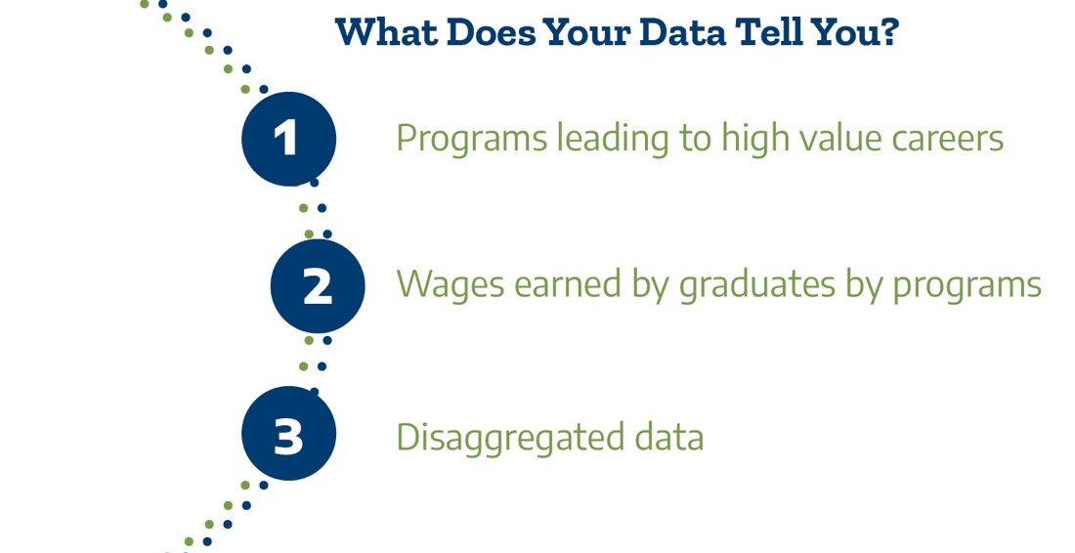

The Next Chapter of Community Colleges

- What were the key takeaways for our Board from Dr. Lennon’s presentation?

- What cultural or policy changes do we need to explore based on these takeaways?

- What are the direct opportunities for further education and high value careers by students completing programs at our college?

By clarifying the value of college programs to students and communities and ensuring equitable access to higher-opportunity programs, community colleges can strengthen their essential role as engines of community recovery and revitalization. (CCRC, 2020)

Review your college’s Post-Secondary Education Outcomes Explorer Dashboard (PSEO). Use the filters on the dashboard to answer the questions. The filters at the bottom allow for exploration by program name.

Dashboard Filters | Questions | Answers
Data Type:  Earnings  State:  Texas  Institution:  Choose your college  Degree Level:  Associates  Graduation Cohort:  2006-2010 (allows for 1- and 5-years post-grad)  Compare earnings by:  Time  Earnings-percentile filter: 50  Program Specificity: General (refers to 2-digit CIP) | Which of our programs lead to relatively higher opportunity in terms of  immediate job earnings?  Which of our programs lead to relatively less opportunity in terms of  immediate job earnings?

Look back at the analysis from team time #1.

Question | Answer
Using the PSEO, what are the earnings associated with the top five programs by enrollment at our college?
Using the PSEO, what are the earnings associated with the top five programs by completion at our college?

Once the delegates have examined student enrollment and completion enrollment in programs classified by whether they lead to higher or lower opportunities post-graduation, the question is whether representation in these programs is equitable. By program equity we refer to whether groups of students (e.g., by race/ethnicity, gender, income) are proportionately represented in access and completion of different college programs. (CCRC, 2021)

Question | Answer
What patterns among subgroups of students do we observe (over-/under-representation) in programs leading to higher opportunities (higher wages)?

What patterns among subgroups of students do we observe (over-/under-representation) in programs leading to lower opportunities (lower wages)?

Question | Answer
How often do we engage business/industry partners in conversations about workforce development and an equitable future workforce?

Please have team members decide which concurrent session they will attend.

John Fink and Davis Jenkins, "Unpacking Program Enrollments and Completions with Equity in Mind," (Community College Research Center, 2020).

