Board of Trustees Institute
Team Strategy Time #1: Monitoring What Matters

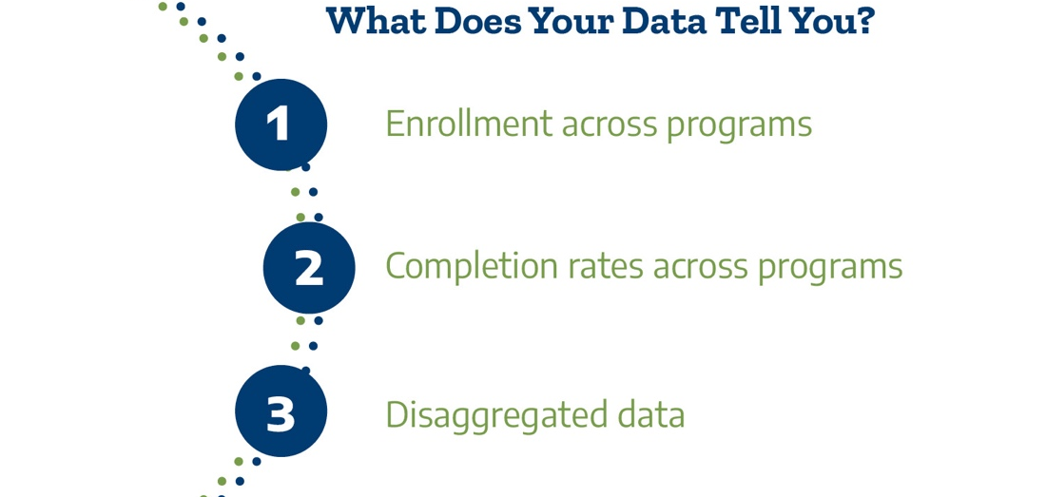

Description

The Texas Pathways strategy calls for decisive and strategic board action to enable an integrated, system-wide approach to student success. Effective pathways are intentionally designed, clear, coherent, and structured educational experiences, informed by available evidence, that guide each student efficiently to their end goals. The Texas Pathways strategy supports learners from multiple entry points from high school, adult education literacy, dual credit, continuing education, credit programs, or the workforce. Whether students arrive right out of high school or as adults looking to reskill or upskill, Texas community colleges must design and implement postsecondary pathways into and through high-quality programs that award high-value credentials, certificates, and degrees aligned with high-demand, high-value careers.

During this first team strategy time, delegates and resident faculty will convene to review data that informs the actions necessary to enable the college CEO and the board to set the climate and expectation for institutional change to implement a comprehensive, equitable student access and success strategy. The Texas Success Center has provided headcount and program completion data that delegates can use to examine program access and completion by race/ethnicity. Using program-level data, delegates will reflect on equitable student access and success and consider board actions necessary to reduce and eliminate disparities in access and completion to improve upward economic mobility.

What programs are students enrolled in and what programs do they complete?

To start, we will examine the composition of the student body and compare that to the composition of students enrolled in certain programs. (Reference for data enrollment dashboard at this link: https://bit.ly/TXProgramEnroll)

Questions | Answers
What are the top 5 programs (by 2-digit CIP) with the highest enrollment?  Are unstructured or undefined program (e.g., general studies, or unknown/undeclared) in your top five programs by enrollment? | Top 5 Programs by Enrollment:
What is the overall number and percentage distribution of students enrolled in all programs for each racial/ethnic category at your college?

If enrollments were to be equitably distributed across race/ethnicity, which groups are over- or under-represented in each top-enrolled program

Next, we will examine the composition of the completers at your college and compare that to the composition of completers in certain programs. (Reference for data completion dashboard at this link: https://bit.ly/TXcompletions)

Questions | Answers
What are the top 5 programs (by 2-digit CIP) with the highest completions? | Top 5 programs by completion
What is the overall number and percentage distribution of students completing awards in all programs for each racial/ethnic category at your college?
If completions were to be equitably distributed by race/ethnicity, which groups are over- or under-represented in the completion of the top 5 programs?

Analysis

Question | Answer
What differences do we see in student enrollment compared with completion of programs?
Based on the data, are there programs that are achieving equity in program access and completion?
Based on these data, what concerns do we have about equity in access to and completion of programs?
How is the importance of equitable access and completion reflected by the Board and in the college strategic plan?

How often do we as a board want to review and discuss disaggregated student metrics at the institutional and program levels?

