Team Strategy Time #2: Cadre 3
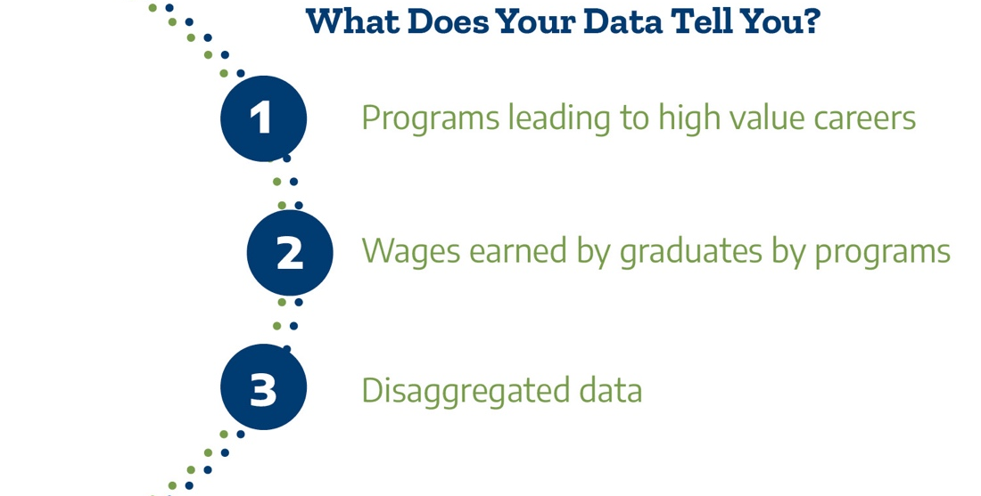

What are the direct opportunities for further education and high value careers by students enrolled and completing programs at our college?

It is especially important to increase opportunity for students from populations that have been underserved in higher education and marginalized in broader society, such as Black, LatinX, and Indigenous students. By clarifying the value of college programs to students and communities and ensuring equitable access to higher-opportunity programs, community colleges can strengthen their essential role as engines of community recovery and revitalization. (CCRC, 2021)

Review your college’s Post-Secondary Education Outcomes Explorer Dashboard (PSEO). Use the filters on the dashboard to answer the questions. The filters at the bottom allow for exploration by program name.

Dashboard Filters | Questions | Answers
Data Type:  Earnings  State:  Texas  Institution:  Choose your college  Degree Level:  Associates  Graduation Cohort:  2006-2010 (allows for 1- and 5-years post-grad)  Compare earnings by:  Time  Earnings-percentile filter: 50  Program Specificity: General (refers to 2-digit CIP) | Which of our programs lead to relatively higher opportunity in terms of  immediate job earnings?  Which of our programs lead to relatively less opportunity in terms of  immediate job earnings?

Once the college has mapped out student enrollment in programs classified by whether
they lead to higher or lower opportunity post-graduation, the question is whether
representation in these programs is equitable. By equity in program enrollments,
we refer to whether groups of students (e.g., by race/ethnicity, gender, income) are
proportionately represented in different college programs. For example, are Black students underrepresented in high earning programs? (CCRC, 2021)

Look back at the analysis from team time #1 to consider the following questions.

Questions | Answers
Are our top three enrollment programs aligned with higher job earnings and opportunity in the PSEO?

Are our top three completion programs aligned with higher job earnings and opportunity in the PSEO?

What patterns among subgroups of students do we observe (over-/under-representation) in programs leading to higher opportunities (higher wages, available jobs)?

Now, use all the information so far to consider institutional actions.

Questions | Answers
Has the college built clear program maps for each of our programs? Are there programs where there is strong student interest or labor market demand for which maps have not been developed?

Are these program maps easily accessible to our students on our website? If not, what resources are needed?

Do our program maps include program learning outcomes aligned with the requirements for success in the further education and employment outcomes by program? If not, what processes need to be put in place?

Do our program maps include labor market data? If not, what resources are needed to include this data?

How do we engage in conversations about pathways that lead to low-wage work and/or low-demand jobs? How will these conversations be brought back to the college as a whole? Who will be involved?

Please upload your completed team time document to the Document Center on the Event Page using the file name: [Your college name]_TPI4 Team Time 2.docx
Please have team members decide which concurrent session they will attend. In team time 3 we will take the first 15 minutes to report back on key learnings from the concurrent session.

