Team Strategy Time #1: Cadre 3

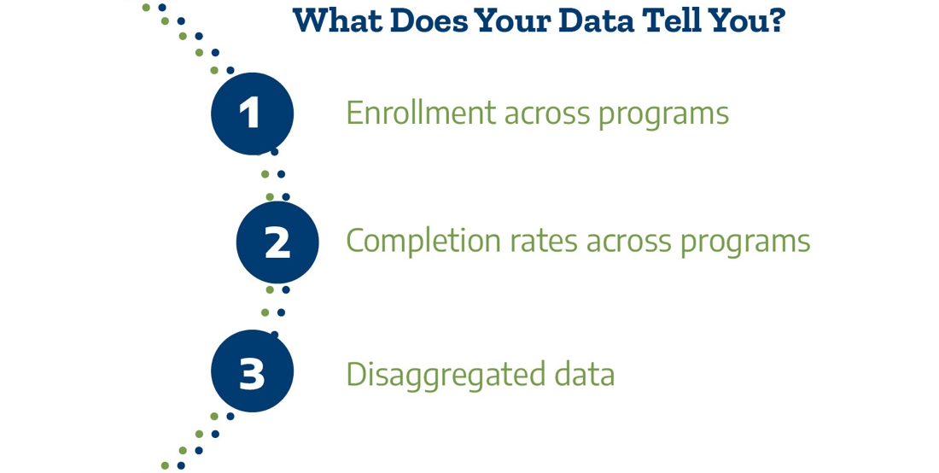

What programs are students enrolled in and what programs do they complete?

To start, we will examine the composition of the student body and compare that to the composition of students enrolled in certain programs using the enrollment dashboard at this link: https://bit.ly/TXProgramEnroll
- Simplify the view to look at your college with the ‘Institution’ filter at the top.
  - Unclick “All” and then click your college name.
- We will be using the filters on the left side to examine several questions. Some filters will remain the same. Set the filters on the right to:
  - Award: (All)
  - Chart Type: Bar Chart recommended (There is also a table option for use if you prefer.)

Adjust the filters to answer the questions. Use the last column to record your answers.

Dashboard Filters | Questions | Answers
Program Specificity:  2-Digit CIP  Program Area:  (All)  Student Type:  Total  Measure Type:  Number of Students | What are the top 3 programs (by 2-digit CIP) with the highest enrollment?  What percentage of students are enrolled in an unstructured or undefined program (e.g., general studies, general transfer, or unknown/undeclared)? | Top Programs by Enrollment:  1.  2.  3.  Students in unstructured programs:
Program Specificity:  All  Program Area:  (All)  Student Type:  Race/Ethnicity  Measure Type:  Percent of Students | What is the overall proportion of students enrolled in all programs for each racial/ethnic category at your college? | American Indian/Alaskan:  Asian:  Black/African American:  Hispanic/Latinx:  White:
Program Specificity:  2-Digit CIP  Program Area:  Select your top 3  Student Type:  Race/Ethnicity  Measure Type:  Percent of Students | Which programs have substantial differences in enrollment in the proportion of Black/African American, Hispanic/Latinx, and Indigenous students, compared to your overall enrollment?  Which groups are over- or under-represented in each top-enrolled program?

Next, we will examine the composition of the completers at your college and compare that to the composition of completers in certain programs using the completion dashboard.
- Simplify the view to look at your college with the ‘Institution’ filter at the top.
  - Unclick “All” and then click your college name.
- We will be using the filters on the left side to examine several questions. Some filters will remain the same. Set the filters on the right to:
  - Program Area: (All)
  - Award: (All)
  - Chart Type: Bar Chart

Use the filters on the dashboard to answer the questions. Use the last column to record your answers.

Dashboard Filters | Questions | Answers
Program Specificity:  2-Digit CIP  Program Area:  (All)  Completer Type:  Total  Measure Type:  Number of Students | What are the top 3 programs (by 2-digit CIP) with the highest completions? | Top Programs by Completion:  1.  2.  3.
Program Specificity:  All  Program Area:  (All)  Completer Type:  Race/Ethnicity  Measure Type:  Percent of Students | What is the overall proportion of students completing awards in all programs for each racial/ethnic category at your college? | American Indian/Alaskan:  Asian:  Black/African American:  Hispanic/Latinx:  White:
Program Specificity: 2-Digit CIP  Program Area:  Select your top 3  Completer Type: Race/Ethnicity  Measure Type: Percent of Students | Which programs have substantial differences in completion in the proportion of Black/African American, Hispanic/Latinx, and Indigenous students, compared to the composition of your overall completions?  Which groups are over- or under-represented in the completion of the top 5 programs?

Analysis: Use the insights from above to consider the following questions.

Questions | Answers
What differences do we see in student enrollment compared with completion of programs?

Based on these data, what equity concerns arise about access and completion at the college as a whole?

Based on these data, what equity concerns arise about access to individual programs?

Based on these data, what equity concerns arise about completion of individual programs?

The dashboards allow for additional exploration by gender and race/ethnicity with gender. The dashboards also allow for program exploration at the 4-digit CIP code level and by award level. If time permits, repeat the exercises above for gender. What do you notice?

Please upload your completed team time document to the Document Center on the Event Page using the file name: [Your college name]_TPI4 Team Time 1.docx

