Team Time #4 Action Plan: Cadre 2
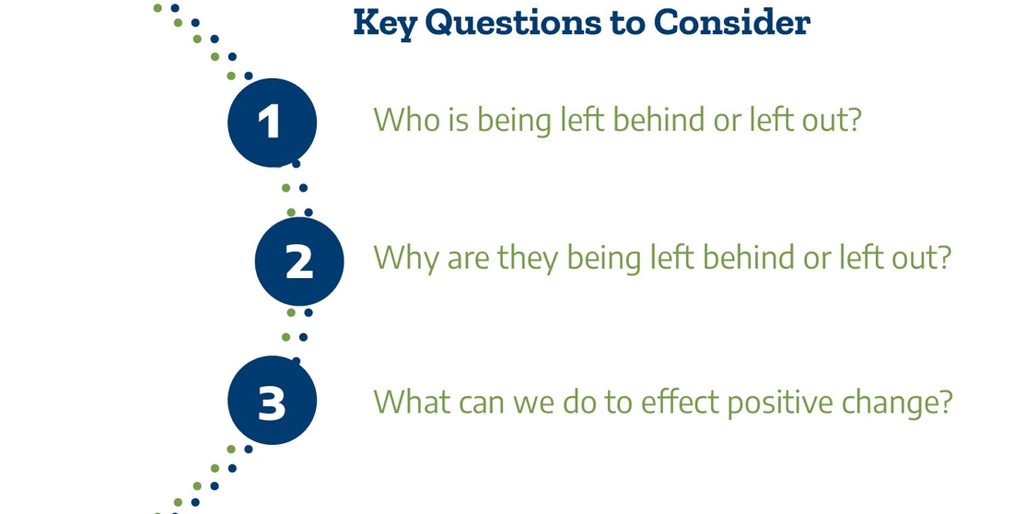

Please answer the following questions about implementing the action plan when you return to the campus.

Questions | Answers
Who at the college needs to be included in the review of disaggregated data in the dashboards and regional LMI information?

How often should we review data dashboards and LMI information to guide decision making for programs and services?

Considering where we are in the Pathways implementation process, what are our next steps to address equity in program access and completion? What are our next steps to align our pathways with employer needs and good jobs?

What onboarding strategies will we explore to improve the student experience for students from all backgrounds?

Please identify 2 to 3 goals for onboarding students, regardless of the point of entry (AEL, CE, dual credit, high school, military, adult returner, displaced worker) to the college. Please put your goals on the Texas Pathways action plan spreadsheet that contains your KPIs and goals from Pathways Institutes 2 and 3.

Please upload your completed team time document to the Document Center on the Event Page using the file name: [Your college name]_TPI 4 Action Plan.docx. Please submit your action plan by December 1, 2021.
Thank you for providing us feedback on the Texas Success Center's Texas Pathways Institute: Onboarding Reimagined. Your anonymous feedback will help us improve our services and resources in the coming year! Please complete the event survey at: www.surveymonkey.com/r/TPI4

