Team Strategy Time #2: Cadre 2

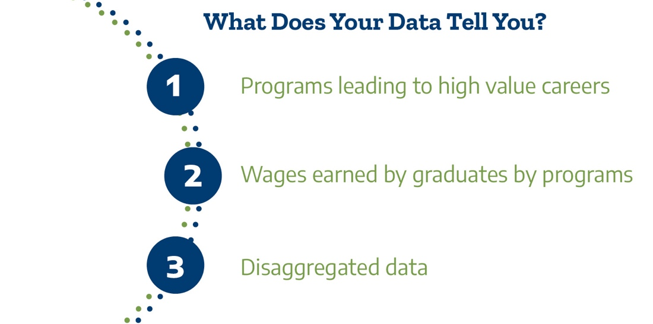

What are the direct opportunities for further education and high value careers by students enrolled and completing programs at our college?

It is especially important to increase opportunity for students from populations that have been underserved in higher education and marginalized in broader society, such as Black, LatinX, and Indigenous students. By clarifying the value of college programs to students and communities and ensuring equitable access to higher-opportunity programs, community colleges can strengthen their essential role as engines of community recovery and revitalization. (CCRC, 2021)

Review your college’s Post-secondary Education Outcomes Explorer Dashboard (PSEO). Use the filters on the dashboard to answer the questions. The filters at the bottom allow for exploration by program name.

Dashboard Filters | Questions | Answers
Data Type:  Earnings  State:  Texas  Institution:  Choose your college  Degree Level:  Associates  Graduation Cohort:  2006-2010 (allows for 1- and 5-years post-grad)  Compare earnings by:  Time  Earnings-percentile filter: 50  Program Specificity: General (refers to 2-digit CIP) | Which of our programs lead to relatively higher opportunity in terms of  immediate job earnings?  Which of our programs lead to relatively less opportunity in terms of  immediate job earnings?

Review your region’s Labor Market Insights (LMI) snapshots.
Questions | Answers
Which of our programs lead to relatively more opportunity in terms of immediate job prospects or opportunities?
Which of our programs lead to relatively less opportunity in terms of immediate job prospects or opportunities?

Look back at the analysis from team time #1.

Questions | Answers
Are our top three enrollment programs aligned with higher job earnings and opportunity in the PSEO and LMI?

Are our top three completion programs aligned with higher job earnings and opportunity in the PSEO and LMI?

Once the college has mapped out student enrollment in programs classified by whether they lead to higher or lower opportunity post-graduation, the question is whether representation in these programs is equitable. By equity in program enrollments, we refer to whether groups of students (e.g., by race/ethnicity, gender, income) are proportionately represented in different college programs. For example, are Black students underrepresented in high earning programs?

- What patterns among subgroups of students do we observe (over-/under-representation) in programs leading to higher opportunities (higher wages, available jobs)?

We will now consider institutional actions.

Question | Answer
Has the college built clear program maps for each of our programs? Are there programs where there is strong student interest or labor market demand for which maps have not been developed?

Are program maps easily accessible to our students on our website? If not, what resources are needed?

Do our program maps include program learning outcomes aligned with the requirements for success in the further education and employment outcomes by program? If not, what processes need to be put in place?

Do our program maps include labor market data? How often is the data updated? If not, what resources are needed?

When will the pathways team engage in conversations about program pathways that lead to low-wage jobs and/or low-demand jobs? How will these conversations be brought back to the college as a whole? Who will be involved?

Please upload your completed team time document to the Document Center on the Event Page using the file name: [Your college name]_TPI4 Team Time 2.docx
Please have team members decide which concurrent session they will attend. In team time 3 we will take the first 15 minutes to report back on key learnings from the concurrent session.

