Team Time #4 Action Plan: Cadre 1+

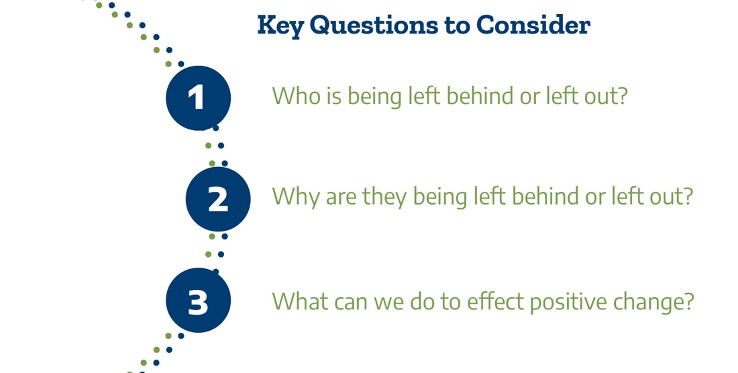

Please answer the following questions about implementing the action plan when you return to the campus.

Question | Answer
Who at the college needs to be included in the review of disaggregated data and regional LMI information?
How often should we review data dashboards and LMI information to guide decision making for programs and services?
What onboarding strategies do we currently use when college data shows inequities by race/ethnicity and/or gender in enrollment to programs that lead to high-value career and/or transfer opportunities?
What onboarding strategies will we explore to improve the student experience for students from all backgrounds?

Please identify 2 to 3 goals for onboarding students, regardless of the point of entry (AEL, CE, dual credit, high school, military, adult returner, displaced worker) to the college. Please put these goals in your TSC action plan spreadsheet that has KPIs and the goals from Pathways Institutes 2 and 3.

Please upload your completed Action Plan document to the Document Center on the Event Page using the file name: [Your college name]_TPI4 Action Plan.docx. Please submit your action plan by December 1, 2021.

Thank you for providing us feedback on the Texas Success Center's Texas Pathways Institute: Onboarding Reimagined. Your anonymous feedback will help us improve our services and resources in the coming year! Please complete the event survey at: www.surveymonkey.com/r/TPI4

