Team Strategy Time #2: Cadre 1+
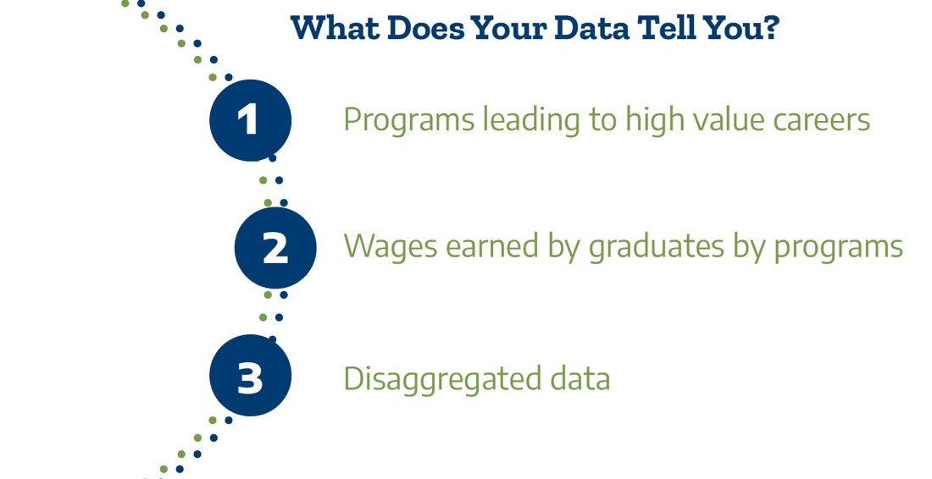

What are the direct opportunities for further education and high value careers by students enrolled and completing programs at our college?
It is especially important to increase opportunity for students from populations that have been underserved in higher education and marginalized in broader society, such as Black, LatinX, and Indigenous students. By clarifying the value of college programs to students and communities and ensuring equitable access to higher-opportunity programs, community colleges can strengthen their essential role as engines of community recovery and revitalization. (CCRC, 2021)

Review your college’s Post-Secondary Education Outcomes Explorer Dashboard (PSEO). Use the filters on the dashboard to answer the questions. The filters at the bottom allow for exploration by program name.

Dashboard Filters | Questions | Answers
Data Type:  Earnings  State:  Texas  Institution:  Choose your college  Degree Level:  Associates  Graduation Cohort:  2006-2010 (allows for 1- and 5-years post-grad)  Compare earnings by:  Time  Earnings-percentile filter: 50  Program Specificity: General (refers to 2-digit CIP) | Which of our programs lead to relatively higher opportunity in terms of  immediate job earnings?  Which of our programs lead to relatively less opportunity in terms of  immediate job earnings?

Review your region’s Labor Market Insights (LMI) snapshots.
Questions | Answers
Which of our programs lead to relatively more opportunity in terms of immediate job prospects or opportunities?
Which of our programs lead to relatively less opportunity in terms of immediate job prospects or opportunities?

Look back at the analysis from team time #1.
Question | Answer
Are our top five enrollment programs aligned with higher job earnings and opportunity in the PSEO and LMI?
Are our top five completion programs aligned with higher job earnings and opportunity in the PSEO and LMI?

Once the college have examined student enrollment in programs classified by whether they lead to higher or lower opportunity post-graduation, the question is whether representation in these programs is equitable. By equity in program enrollments, we refer to whether groups of students (e.g., by race/ethnicity, gender, income) are proportionately represented in different college programs. For example, are Black students underrepresented in high earning programs? (CCRC, 2021)

Question | Answer
What patterns among subgroups of students do we observe (over-/under-representation) in programs leading to higher opportunities (higher wages, available jobs)?

What patterns among subgroups of students do we observe (over-/under-representation) in programs leading to lower opportunities (lower wages, fewer jobs)?

Research and practice tell us that students need to have a clear academic plan early in their college experience, preferably upon entry to the college. We will now consider institutional actions to support this goal.

Question | Answer
Are there programs where there is strong student interest or labor market demand for which program maps have not been developed?
Are there current programs that could be expanded to include short-term credentials?
What mechanisms are in place to ensure maps are regularly updated and continually improved, including labor market information?
What processes do we use to understand the levels of student engagement, clarity, and accessibility of content of these maps?
How often do we engage business/industry partners in conversations about the future workforce? What do we do in addition to advisory committees?
How do we include business and industry leaders in conversations about our transfer programs? AEL? Continuing education?
Please upload your completed team time document to the Document Center on the Event Page using the file name: [Your college name]_TPI4 Team Time 2.docx
Please have team members decide which concurrent session they will attend. In team time 3 we will take the first 15 minutes to report back on key learnings from the concurrent session.

